UNITED STATES
SECURITIES AND EXCHANGE COMMISSION
Washington, D.C. 20549

FORM 8-K

CURRENT REPORT
Pursuant to Section 13 or 15(d)
of the Securities Exchange Act of 1934
Date of report (Date of earliest event reported): August 4, 2026

VROOM, INC.
(Exact name of registrant as specified in its charter)

Delaware |  | 001-39315 |  | 90-1112566
(State or other jurisdiction  of incorporation or organization) |  | (Commission  File Number) |  | (I.R.S. Employer  Identification No.)
4700 Mercantile Dr.
Fort Worth, TX 76137
(Address of principal executive offices) (Zip Code)

(518) 535-9125
(Registrant’s telephone number, include area code)
N/A
(Former Name or Former Address, if Changed Since Last Report)

Check the appropriate box below if the Form 8-K filing is intended to simultaneously satisfy the filing obligation of the registrant under any of the following provisions:

☐ | Written communications pursuant to Rule 425 under the Securities Act (17 CFR 230.425)

☐ | Soliciting material pursuant to Rule 14a-12 under the Exchange Act (17 CFR 240.14a-12)

☐ | Pre-commencement communications pursuant to Rule 14d-2(b) under the Exchange Act (17 CFR 240.14d-2(b))
☐ | Pre-commencement communications pursuant to Rule 13e-4(c) under the Exchange Act (17 CFR 240.13e-4(c))
Securities registered pursuant to Section 12(b) of the Act:

Title of each class | Trading Symbol(s) | Name of each exchange on which registered
Common Stock, $0.001 par value per share | VRM | The Nasdaq Global Market

Indicate by check mark whether the registrant is an emerging growth company as defined in Rule 405 of the Securities Act of 1933 (§230.405 of this chapter) or Rule 12b-2 of the Securities Exchange Act of 1934 (§240.12b-2 of this chapter).
Emerging growth company ☐
If an emerging growth company, indicate by check mark if the registrant has elected not to use the extended transition period for complying with any new or revised financial accounting standards provided pursuant to Section 13(a) of the Exchange Act. ☐

Item 2.02. Results of Operations and Financial Condition.
On August 4, 2026, Vroom, Inc. (the “Company”) issued a press release announcing its financial results for the quarter ended June 30, 2026. A copy of the press release is furnished as Exhibit 99.1 to this Current Report on Form 8-K.

Item 7.01. Regulation FD Disclosure.
On August 4, 2026, the Company posted a corporate slide presentation with financial results for the quarter ended June 30, 2026 on its investor relations website, https://ir.vroom.com/news-events/events-and-presentations. The presentation is furnished as Exhibit 99.2 to this Current Report on Form 8-K and will accompany management’s comments.

The information contained in Item 2.02, including Exhibit 99.1 hereto, and in Item 7.01, including Exhibit 99.2 hereto, shall not be deemed “filed” for purposes of Section 18 of the Securities Exchange Act of 1934, as amended (the “Exchange Act”), or otherwise subject to the liabilities of that section, nor shall it be deemed incorporated by reference in any filing made by the Company under the Securities Act of 1933, as amended, or the Exchange Act, regardless of any general incorporation language in such filings, unless expressly incorporated by specific reference in such filing.
Item 9.01. Financial Statements and Exhibits.
(d) Exhibits.
The following exhibits relating to Item 2.02 and Item 7.01 shall be deemed to be furnished, and not filed:

Exhibit No. |  | Description
99.1 |  | Press Release dated August 4, 2026.
99.2 |  | Earnings Presentation for the Quarter Ended June 30, 2026.
104 |  | Cover Page Interactive Data File (embedded within the Inline XBRL document).

SIGNATURES
Pursuant to the requirements of the Securities Exchange Act of 1934, the registrant has duly caused this report to be signed on its behalf by the undersigned hereunto duly authorized.

 |  | VROOM, INC.
Date: August 4, 2026 |  | By: |  | /s/ Tom Shortt
 |  |  |  | Tom Shortt
 |  |  |  | Chief Executive Officer


Exhibit 99.1

Vroom Announces Second Quarter 2026 Results
First Time in Company History Vroom Achieves Positive Net Income and Adjusted Net Income
NEW YORK – August 4, 2026 – Vroom, Inc. (Nasdaq:VRM) today announced financial results for the second quarter ended June 30, 2026.

HIGHLIGHTS OF SECOND QUARTER 2026
•
$99.8 million stockholders' equity as of June 30, 2026 and $88.4 million tangible book value(1) as of June 30, 2026
•
$63.9 million consolidated total available liquidity(2) as of June 30, 2026, consisting of:
o
$16.4 million cash and cash equivalents
o
$10.5 million of liquidity available to UACC under the warehouse credit facilities
o
$27.0 million of available liquidity from delayed draw facility
o
$10.0 million of available liquidity from 2032 Notes
•
$0.6 million net income for the second quarter 2026
•
$(0.1) million net loss attributable to controlling interest and common shareholders for the second quarter 2026
•
$1.5 million adjusted net income(3) for the second quarter 2026
•
$12.4 million increase in net loss and $20.6 million decrease in adjusted net loss(3) for the trailing twelve months ended June 30, 2026 compared to trailing twelve months ended June 30, 2025
•
$28.5 million existing notes exchanged for $50.0 million new Senior Secured Delayed Draw Convertible Note due 2032
(1) | Tangible book value is a non-GAAP measure and represents total stockholders' equity of $99.8 million, excluding intangible assets of $11.4 million as of June 30, 2026.
(2) | Total available liquidity is a non-GAAP measure and represents $16.4 million of unrestricted cash and cash equivalents, as well as $10.5 million of availability from warehouse credit facilities, $27.0 million of availability from delayed draw facility and $10.0 million of availability from 2032 Notes.
(3) | Adjusted net income (loss) is a non-GAAP measure. For definitions and a reconciliation to the most comparable GAAP measure, please see Non-GAAP Financial Measures section below.

Tom Shortt, Chief Executive Officer of Vroom, said, "In the second quarter of 2026, we achieved positive net income and adjusted net income for the first time in Vroom's history, while continuing to make significant investments in our Next-Generation Technology Platform, driven by improvement in realized and unrealized losses at UACC as we see the benefits of our refreshed internal customer scoring model, which was implemented in 2025. This significant milestone reflects the progress we've made executing our Long-Term Strategic Plan."
Jon Sandison, Chief Financial Officer of Vroom, added, "During the second quarter, we further strengthened our balance sheet by exchanging $28.5 million of existing notes for $50.0 million of new Senior Secured Delayed Draw Convertible Notes due 2032, extending our runway to execute our long-term strategy. We ended the quarter with total available liquidity of $63.9 million, and remain focused on disciplined expense management."

Fresh Start Accounting
As a result of emerging from a voluntary proceeding (the “Prepackaged Chapter 11 Case”) under Chapter 11 of the United States Code, 11 U.S.C. §§ 101-1532, as amended from time to time, on January 14, 2025, (the "Effective Date") and qualifying for the application of fresh-start accounting, at the Effective Date, Vroom’s assets and liabilities were recorded at their estimated fair values which, in some cases, are significantly different than amounts included in our financial statements prior to the Effective Date. Accordingly, our consolidated financial statements after the Effective Date are not comparable with our consolidated financial statements on or before that date. References to “Successor” relate to our financial position and results of operations after the Effective Date. References to “Predecessor” refer to our financial position and results of operations on or before the Effective Date.
The combined results (referenced as “Non-GAAP Combined” or “Combined”) for the three months ended March 31, 2025, represent the sum of the reported amounts for the Predecessor period from January 1, 2025, through January 14, 2025, and the Successor period from January 15, 2025, through March 31, 2025. These combined results are not considered to be prepared in accordance with U.S. generally accepted accounting principles ("GAAP") and have not been prepared as pro forma results per applicable regulations. The combined operating results do not reflect the actual results we would have achieved absent our emergence from the Prepackaged Chapter 11 Case and are not necessarily indicative of future results. Accordingly, the results for the combined three months ended March 31, 2025, (prepared on a Non-GAAP basis) and three months ended March 31, 2026, (prepared on a GAAP basis) may not be comparable, particularly for statement of operations line items significantly impacted by the reorganization transactions and the impact of fresh start accounting.
2

SECOND QUARTER 2026 FINANCIAL DISCUSSION

All financial comparisons are on a year-over-year basis unless otherwise noted. The following financial information is unaudited.

 |  | Three Months Ended June 30,
 |  | 2026 |  |  |  | 2025 |  |  |  |  | $ Change |  |  |  | % Change
 |  | (in thousands)
Interest income |  | $ | 43,605 |  |  | $ | 45,748 |  |  |  | $ | (2,143 | ) |  |  | (4.7 | )%
Interest expense:
Warehouse credit facility |  |  | 3,396 |  |  |  | 3,259 |  |  |  |  | 137 |  |  |  | 4.2 | %
Securitization debt |  |  | 8,586 |  |  |  | 9,883 |  |  |  |  | (1,297 | ) |  |  | (13.1 | )%
Total interest expense |  |  | 11,982 |  |  |  | 13,142 |  |  |  |  | (1,160 | ) |  |  | (8.8 | )%
Net interest income |  |  | 31,623 |  |  |  | 32,606 |  |  |  |  | (983 | ) |  |  | (3.0 | )%
Realized and unrealized losses, net of recoveries |  |  | 10,663 |  |  |  | 19,500 |  |  |  |  | (8,837 | ) |  |  | (45.3 | )%
Net interest income after losses and recoveries |  |  | 20,960 |  |  |  | 13,106 |  |  |  |  | 7,854 |  |  |  | 59.9 | %
Noninterest income:
Servicing income |  |  | 925 |  |  |  | 1,259 |  |  |  |  | (334 | ) |  |  | (26.5 | )%
Warranties and GAP income, net |  |  | 3,291 |  |  |  | 3,645 |  |  |  |  | (354 | ) |  |  | (9.7 | )%
CarStory revenue |  |  | 1,297 |  |  |  | 1,846 |  |  |  |  | (549 | ) |  |  | (29.7 | )%
Other income |  |  | 3,156 |  |  |  | 2,067 |  |  |  |  | 1,089 |  |  |  | 52.7 | %
Total noninterest income |  |  | 8,669 |  |  |  | 8,817 |  |  |  |  | (148 | ) |  |  | (1.7 | )%
Expenses:
Compensation and benefits |  |  | 18,751 |  |  |  | 21,091 |  |  |  |  | (2,340 | ) |  |  | (11.1 | )%
Professional fees |  |  | 1,984 |  |  |  | 2,013 |  |  |  |  | (29 | ) |  |  | (1.4 | )%
Software and IT costs |  |  | 3,244 |  |  |  | 3,420 |  |  |  |  | (176 | ) |  |  | (5.1 | )%
Depreciation and amortization |  |  | 1,482 |  |  |  | 742 |  |  |  |  | 740 |  |  |  | 99.7 | %
Interest expense on corporate debt |  |  | 1,063 |  |  |  | 698 |  |  |  |  | 365 |  |  |  | 52.3 | %
Other expenses |  |  | 2,574 |  |  |  | 2,832 |  |  |  |  | (258 | ) |  |  | (9.1 | )%
Total expenses |  |  | 29,098 |  |  |  | 30,796 |  |  |  |  | (1,698 | ) |  |  | (5.5 | )%
Income (loss) from continuing operations before provision for income taxes |  |  | 531 |  |  |  | (8,873 | ) |  |  |  | 9,404 |  |  |  | 106.0 | %
(Benefit) provision for income taxes from continuing operations |  |  | (24 | ) |  |  | 59 |  |  |  |  | (83 | ) |  |  | (140.7 | )%
Net income (loss) from continuing operations |  | $ | 555 |  |  | $ | (8,932 | ) |  |  | $ | 9,487 |  |  |  | 106.2 | %
Net income from discontinued operations |  | $ | 73 |  |  | $ | 413 |  |  |  | $ | (340 | ) |  |  | (82.3 | )%
Net income (loss) |  | $ | 628 |  |  | $ | (8,519 | ) |  |  | $ | 9,147 |  |  |  | 107.4 | %
Preferred stock dividends attributable to noncontrolling interests of subsidiary |  | $ | (691 | ) |  | $ | — |  |  |  | $ | (691 | ) |  |  | 100.0 | %
Net loss attributable to controlling interest and common shareholders |  | $ | (63 | ) |  | $ | (8,519 | ) |  |  | $ | 8,456 |  |  |  | 99.3 | %

3

 |  | Successor |  |  |  |  |  |  |  |  | Predecessor |  |  |  | Non-GAAP Combined |  |  |  | Non-GAAP |  |  |  | Non-GAAP
 |  | Six months ended June 30, |  |  |  | Period from January 15 through June 30, |  |  |  |  | Period from January 1 through January 14, |  |  |  | Six months ended June 30,
 |  | 2026 |  |  |  | 2025 |  |  |  |  | 2025 |  |  |  | 2025 |  |  |  | $ Change |  |  |  | % Change
 |  | (in thousands)
Interest income |  | $ | 86,081 |  |  | $ | 82,905 |  |  |  | $ | 7,183 |  |  | $ | 90,088 |  |  | $ | (4,007 | ) |  |  | (4.4 | )%
Interest expense:
Warehouse credit facility |  |  | 6,835 |  |  |  | 7,877 |  |  |  |  | 1,017 |  |  |  | 8,894 |  |  |  | (2,059 | ) |  |  | (23.2 | )%
Securitization debt |  |  | 17,206 |  |  |  | 16,431 |  |  |  |  | 1,178 |  |  |  | 17,609 |  |  |  | (403 | ) |  |  | (2.3 | )%
Total interest expense |  |  | 24,041 |  |  |  | 24,308 |  |  |  |  | 2,195 |  |  |  | 26,503 |  |  |  | (2,462 | ) |  |  | (9.3 | )%
Net interest income |  |  | 62,040 |  |  |  | 58,597 |  |  |  |  | 4,988 |  |  |  | 63,585 |  |  |  | (1,545 | ) |  |  | (2.4 | )%
Realized and unrealized losses, net of recoveries |  |  | 35,346 |  |  |  | 30,600 |  |  |  |  | 6,792 |  |  |  | 37,392 |  |  |  | (2,046 | ) |  |  | (5.5 | )%
Net interest income (loss) after losses and recoveries |  |  | 26,694 |  |  |  | 27,997 |  |  |  |  | (1,804 | ) |  |  | 26,193 |  |  |  | 501 |  |  |  | 1.9 | %
Noninterest income:
Servicing income |  |  | 2,064 |  |  |  | 2,513 |  |  |  |  | 192 |  |  |  | 2,705 |  |  |  | (641 | ) |  |  | (23.7 | )%
Warranties and GAP income, net |  |  | 5,977 |  |  |  | 7,724 |  |  |  |  | 307 |  |  |  | 8,031 |  |  |  | (2,054 | ) |  |  | (25.6 | )%
CarStory revenue |  |  | 2,630 |  |  |  | 4,238 |  |  |  |  | 432 |  |  |  | 4,670 |  |  |  | (2,040 | ) |  |  | (43.7 | )%
Other income |  |  | 5,197 |  |  |  | 4,548 |  |  |  |  | 113 |  |  |  | 4,661 |  |  |  | 536 |  |  |  | 11.5 | %
Total noninterest income |  |  | 15,868 |  |  |  | 19,023 |  |  |  |  | 1,044 |  |  |  | 20,067 |  |  |  | (4,199 | ) |  |  | (20.9 | )%
Expenses:
Compensation and benefits |  |  | 37,897 |  |  |  | 37,158 |  |  |  |  | 2,823 |  |  |  | 39,981 |  |  |  | (2,084 | ) |  |  | (5.2 | )%
Professional fees |  |  | 6,504 |  |  |  | 7,360 |  |  |  |  | 297 |  |  |  | 7,657 |  |  |  | (1,153 | ) |  |  | (15.1 | )%
Software and IT costs |  |  | 6,405 |  |  |  | 5,822 |  |  |  |  | 457 |  |  |  | 6,279 |  |  |  | 126 |  |  |  | 2.0 | %
Depreciation and amortization |  |  | 2,822 |  |  |  | 1,317 |  |  |  |  | 1,057 |  |  |  | 2,374 |  |  |  | 448 |  |  |  | 18.9 | %
Interest expense on corporate debt |  |  | 2,275 |  |  |  | 1,178 |  |  |  |  | 176 |  |  |  | 1,354 |  |  |  | 921 |  |  |  | 68.0 | %
Impairment charges |  |  | — |  |  |  | 4,156 |  |  |  |  | — |  |  |  | 4,156 |  |  |  | (4,156 | ) |  |  | (100.0 | )%
Other expenses |  |  | 4,982 |  |  |  | 5,202 |  |  |  |  | 371 |  |  |  | 5,573 |  |  |  | (591 | ) |  |  | (10.6 | )%
Total expenses |  |  | 60,885 |  |  |  | 62,193 |  |  |  |  | 5,181 |  |  |  | 67,374 |  |  |  | (6,489 | ) |  |  | (9.6 | )%
Income (loss) from continuing operations before provision for income taxes |  |  | (18,323 | ) |  |  | (15,173 | ) |  |  |  | (5,941 | ) |  |  | (21,114 | ) |  |  | 2,791 |  |  |  | 13.2 | %
Reorganization items, net |  |  | — |  |  |  | — |  |  |  |  | 51,036 |  |  |  | 51,036 |  |  |  | (51,036 | ) |  |  | (100.0 | )%
(Loss) income from continuing operations before provision for income taxes |  |  | (18,323 | ) |  |  | (15,173 | ) |  |  |  | 45,095 |  |  |  | 29,922 |  |  |  | (48,245 | ) |  |  | (161.2 | )%
Provision for income taxes from continuing operations |  |  | 168 |  |  |  | 209 |  |  |  |  | 5 |  |  |  | 214 |  |  |  | (46 | ) |  |  | (21.5 | )%
Net (loss) income from continuing operations |  | $ | (18,491 | ) |  | $ | (15,382 | ) |  |  | $ | 45,090 |  |  | $ | 29,708 |  |  | $ | (48,199 | ) |  |  | (162.2 | )%
Net income (loss) from discontinued operations |  | $ | 61 |  |  | $ | 512 |  |  |  | $ | (4 | ) |  | $ | 508 |  |  | $ | (447 | ) |  |  | (88.0 | )%
Net (loss) income |  | $ | (18,430 | ) |  | $ | (14,870 | ) |  |  | $ | 45,086 |  |  | $ | 30,216 |  |  | $ | (48,646 | ) |  |  | (161.0 | )%
Preferred stock dividends attributable to noncontrolling interests of subsidiary |  | $ | (1,262 | ) |  | $ | — |  |  |  | $ | — |  |  | $ | — |  |  | $ | (1,262 | ) |  |  | 100.0 | %
Net (loss) income attributable to controlling interest and common shareholders |  | $ | (19,692 | ) |  | $ | (14,870 | ) |  |  | $ | 45,086 |  |  | $ | 30,216 |  |  | $ | (49,908 | ) |  |  | (165.2 | )%

4

Results by Segment

UACC

 | Three Months Ended June 30,
 | 2026 |  |  |  |  | 2025 |  |  |  |  | Change |  |  |  | % Change
 | (in thousands)
Interest income | $ | 43,605 |  |  |  | $ | 45,748 |  |  |  | $ | (2,143 | ) |  |  | (4.7 | )%
Interest expense:
Warehouse credit facility |  | 3,396 |  |  |  |  | 3,259 |  |  |  |  | 137 |  |  |  | 4.2 | %
Securitization debt |  | 8,586 |  |  |  |  | 9,883 |  |  |  |  | (1,297 | ) |  |  | (13.1 | )%
Total interest expense |  | 11,982 |  |  |  |  | 13,142 |  |  |  |  | (1,160 | ) |  |  | (8.8 | )%
Net interest income |  | 31,623 |  |  |  |  | 32,606 |  |  |  |  | (983 | ) |  |  | (3.0 | )%
Realized and unrealized losses, net of recoveries |  | 10,757 |  |  |  |  | 20,922 |  |  |  |  | (10,165 | ) |  |  | (48.6 | )%
Net interest income after losses and recoveries |  | 20,866 |  |  |  |  | 11,684 |  |  |  |  | 9,182 |  |  |  | 78.6 | %
Noninterest income:
Servicing income |  | 925 |  |  |  |  | 1,259 |  |  |  |  | (334 | ) |  |  | (26.5 | )%
Warranties and GAP income, net |  | 3,203 |  |  |  |  | 3,673 |  |  |  |  | (470 | ) |  |  | (12.8 | )%
Other income |  | 3,119 |  |  |  |  | 1,978 |  |  |  |  | 1,141 |  |  |  | 57.7 | %
Total noninterest income |  | 7,247 |  |  |  |  | 6,910 |  |  |  |  | 337 |  |  |  | 4.9 | %
Expenses:
Compensation and benefits |  | 16,352 |  |  |  |  | 17,443 |  |  |  |  | (1,091 | ) |  |  | (6.3 | )%
Professional fees |  | 989 |  |  |  |  | 1,433 |  |  |  |  | (444 | ) |  |  | (31.0 | )%
Software and IT costs |  | 3,179 |  |  |  |  | 2,688 |  |  |  |  | 491 |  |  |  | 18.3 | %
Depreciation and amortization |  | 1,381 |  |  |  |  | 628 |  |  |  |  | 753 |  |  |  | 119.9 | %
Interest expense on corporate debt |  | 765 |  |  |  |  | 698 |  |  |  |  | 67 |  |  |  | 9.6 | %
Other expenses |  | 2,053 |  |  |  |  | 2,152 |  |  |  |  | (99 | ) |  |  | (4.6 | )%
Total expenses |  | 24,719 |  |  |  |  | 25,042 |  |  |  |  | (323 | ) |  |  | (1.3 | )%
Preferred stock dividends attributable to noncontrolling interests of subsidiary |  | (691 | ) |  |  |  | — |  |  |  |  | (691 | ) |  |  | 100.0 | %
Adjusted net income (loss) | $ | 3,993 |  |  |  | $ | (5,334 | ) |  |  | $ | 9,327 |  |  |  | 174.9 | %
Stock compensation expense | $ | 1,139 |  |  |  | $ | 1,106 |  |  |  | $ | 33 |  |  |  | 3.0 | %
Severance | $ | 151 |  |  |  | $ | 7 |  |  |  | $ | 144 |  |  |  | 2,057.1 | %

5

 | Successor |  |  |  |  |  |  |  |  |  | Predecessor |  |  |  | Non-GAAP Combined |  |  |  | Non-GAAP |  |  |  | Non-GAAP
 | Six months ended June 30, |  |  |  |  | Period from January 15 through June 30, |  |  |  |  | Period from January 1 through January 14, |  |  |  | Six months ended June 30,
 | 2026 |  |  |  |  | 2025 |  |  |  |  | 2025 |  |  |  | 2025 |  |  |  | Change |  |  |  | % Change
 | (in thousands)
Interest income | $ | 86,081 |  |  |  | $ | 82,905 |  |  |  | $ | 7,254 |  |  | $ | 90,159 |  |  | $ | (4,078 | ) |  |  | (4.5 | )%
Interest expense:
Warehouse credit facility |  | 6,835 |  |  |  |  | 7,877 |  |  |  |  | 1,017 |  |  |  | 8,894 |  |  |  | (2,059 | ) |  |  | (23.2 | )%
Securitization debt |  | 17,206 |  |  |  |  | 16,431 |  |  |  |  | 1,178 |  |  |  | 17,609 |  |  |  | (403 | ) |  |  | (2.3 | )%
Total interest expense |  | 24,041 |  |  |  |  | 24,308 |  |  |  |  | 2,195 |  |  |  | 26,503 |  |  |  | (2,462 | ) |  |  | (9.3 | )%
Net interest income |  | 62,040 |  |  |  |  | 58,597 |  |  |  |  | 5,059 |  |  |  | 63,656 |  |  |  | (1,616 | ) |  |  | (2.5 | )%
Realized and unrealized losses, net of recoveries |  | 35,580 |  |  |  |  | 33,612 |  |  |  |  | 7,647 |  |  |  | 41,259 |  |  |  | (5,679 | ) |  |  | (13.8 | )%
Net interest income (loss) after losses and recoveries |  | 26,460 |  |  |  |  | 24,985 |  |  |  |  | (2,588 | ) |  |  | 22,397 |  |  |  | 4,063 |  |  |  | 18.1 | %
Noninterest income:
Servicing income |  | 2,064 |  |  |  |  | 2,513 |  |  |  |  | 192 |  |  |  | 2,705 |  |  |  | (641 | ) |  |  | (23.7 | )%
Warranties and GAP income, net |  | 5,968 |  |  |  |  | 7,244 |  |  |  |  | 390 |  |  |  | 7,634 |  |  |  | (1,666 | ) |  |  | (21.8 | )%
Other income |  | 5,126 |  |  |  |  | 4,213 |  |  |  |  | 66 |  |  |  | 4,279 |  |  |  | 847 |  |  |  | 19.8 | %
Total noninterest income |  | 13,158 |  |  |  |  | 13,970 |  |  |  |  | 648 |  |  |  | 14,618 |  |  |  | (1,460 | ) |  |  | (10.0 | )%
Expenses:
Compensation and benefits |  | 33,089 |  |  |  |  | 31,137 |  |  |  |  | 2,398 |  |  |  | 33,535 |  |  |  | (446 | ) |  |  | (1.3 | )%
Professional fees |  | 4,353 |  |  |  |  | 4,502 |  |  |  |  | 172 |  |  |  | 4,674 |  |  |  | (321 | ) |  |  | (6.9 | )%
Software and IT costs |  | 6,144 |  |  |  |  | 4,774 |  |  |  |  | 367 |  |  |  | 5,141 |  |  |  | 1,003 |  |  |  | 19.5 | %
Depreciation and amortization |  | 2,616 |  |  |  |  | 1,107 |  |  |  |  | 817 |  |  |  | 1,924 |  |  |  | 692 |  |  |  | 36.0 | %
Interest expense on corporate debt |  | 1,526 |  |  |  |  | 1,178 |  |  |  |  | 85 |  |  |  | 1,263 |  |  |  | 263 |  |  |  | 20.8 | %
Impairment charges |  | — |  |  |  |  | 3,479 |  |  |  |  | — |  |  |  | 3,479 |  |  |  | (3,479 | ) |  |  | (100.0 | )%
Other expenses |  | 4,020 |  |  |  |  | 3,822 |  |  |  |  | 262 |  |  |  | 4,084 |  |  |  | (64 | ) |  |  | (1.6 | )%
Total expenses |  | 51,748 |  |  |  |  | 49,999 |  |  |  |  | 4,101 |  |  |  | 54,100 |  |  |  | (2,352 | ) |  |  | (4.3 | )%
Provision for income taxes from continuing operations |  | — |  |  |  |  | 39 |  |  |  |  | — |  |  |  | 39 |  |  |  | (39 | ) |  |  | (100.0 | )%
Preferred stock dividends attributable to noncontrolling interests of subsidiary |  | (1,262 | ) |  |  |  | — |  |  |  |  | — |  |  |  | — |  |  |  | (1,262 | ) |  |  | 100.0 | %
Adjusted net loss | $ | (10,983 | ) |  |  | $ | (6,168 | ) |  |  | $ | (5,910 | ) |  | $ | (12,078 | ) |  | $ | 1,095 |  |  |  | 9.1 | %
Stock compensation expense | $ | 2,258 |  |  |  | $ | 1,408 |  |  |  | $ | 127 |  |  | $ | 1,535 |  |  | $ | 722 |  |  |  | 47.1 | %
Severance | $ | 151 |  |  |  | $ | 28 |  |  |  | $ | 4 |  |  | $ | 32 |  |  | $ | 119 |  |  |  | 370.7 | %

6

CarStory

 | Three Months Ended June 30,
 | 2026 |  |  |  |  | 2025 |  |  |  |  | Change |  |  |  | % Change
 | (in thousands)
Noninterest income:
CarStory revenue | $ | 1,297 |  |  |  | $ | 1,846 |  |  |  | $ | (549 | ) |  |  | (29.7 | )%
Other income |  | 37 |  |  |  |  | 35 |  |  |  |  | 2 |  |  |  | 5.7 | %
Total noninterest income |  | 1,334 |  |  |  |  | 1,881 |  |  |  |  | (547 | ) |  |  | (29.1 | )%
Expenses:
Compensation and benefits |  | 1,266 |  |  |  |  | 1,581 |  |  |  |  | (315 | ) |  |  | (19.9 | )%
Professional fees |  | 42 |  |  |  |  | (67 | ) |  |  |  | 109 |  |  |  | 162.7 | %
Software and IT costs |  | 2 |  |  |  |  | 3 |  |  |  |  | (1 | ) |  |  | (33.3 | )%
Depreciation and amortization |  | 101 |  |  |  |  | 114 |  |  |  |  | (13 | ) |  |  | (11.4 | )%
Other expenses |  | 102 |  |  |  |  | 136 |  |  |  |  | (34 | ) |  |  | (25.0 | )%
Total expenses |  | 1,513 |  |  |  |  | 1,767 |  |  |  |  | (254 | ) |  |  | (14.4 | )%
Provision for income taxes from continuing operations |  | 31 |  |  |  |  | 33 |  |  |  |  | (2 | ) |  |  | (6.1 | )%
Adjusted net (loss) income | $ | (156 | ) |  |  | $ | 124 |  |  |  | $ | (280 | ) |  |  | (225.8 | )%
Stock compensation expense | $ | 23 |  |  |  | $ | 43 |  |  |  | $ | (20 | ) |  |  | (45.9 | )%
Severance | $ | 31 |  |  |  | $ | — |  |  |  | $ | 31 |  |  |  | 100.0 | %

 | Successor |  |  |  |  |  |  |  |  |  | Predecessor |  |  |  | Non-GAAP Combined |  |  |  | Non-GAAP |  |  |  | Non-GAAP
 | Six months ended June 30, |  |  |  |  | Period from January 15 through June 30, |  |  |  |  | Period from January 1 through January 14, |  |  |  | Six months ended June 30,
 | 2026 |  |  |  |  | 2025 |  |  |  |  | 2025 |  |  |  | 2025 |  |  |  | Change |  |  |  | % Change
 | (in thousands)
Noninterest income:
CarStory revenue | $ | 2,630 |  |  |  | $ | 4,238 |  |  |  | $ | 432 |  |  | $ | 4,670 |  |  | $ | (2,040 | ) |  |  | (43.7 | )%
Other income |  | 71 |  |  |  |  | 97 |  |  |  |  | 13 |  |  |  | 110 |  |  |  | (39 | ) |  |  | (35.5 | )%
Total noninterest income |  | 2,701 |  |  |  |  | 4,335 |  |  |  |  | 445 |  |  |  | 4,780 |  |  |  | (2,079 | ) |  |  | (43.5 | )%
Expenses:
Compensation and benefits |  | 2,509 |  |  |  |  | 2,941 |  |  |  |  | 326 |  |  |  | 3,267 |  |  |  | (758 | ) |  |  | (23.2 | )%
Professional fees |  | 94 |  |  |  |  | (67 | ) |  |  |  | 13 |  |  |  | (54 | ) |  |  | 148 |  |  |  | 274.1 | %
Software and IT costs |  | 4 |  |  |  |  | 3 |  |  |  |  | 2 |  |  |  | 5 |  |  |  | (1 | ) |  |  | (20.0 | )%
Depreciation and amortization |  | 206 |  |  |  |  | 210 |  |  |  |  | 240 |  |  |  | 450 |  |  |  | (244 | ) |  |  | (54.2 | )%
Other expenses |  | 195 |  |  |  |  | 274 |  |  |  |  | 20 |  |  |  | 294 |  |  |  | (99 | ) |  |  | (33.7 | )%
Total expenses |  | 3,008 |  |  |  |  | 3,361 |  |  |  |  | 601 |  |  |  | 3,962 |  |  |  | (954 | ) |  |  | (24.1 | )%
Provision for income taxes from continuing operations |  | 57 |  |  |  |  | 49 |  |  |  |  | 5 |  |  |  | 54 |  |  |  | 3 |  |  |  | 5.6 | %
Adjusted net (loss) income | $ | (286 | ) |  |  | $ | 963 |  |  |  | $ | (153 | ) |  | $ | 810 |  |  | $ | (1,096 | ) |  |  | (135.3 | )%
Stock compensation expense | $ | 47 |  |  |  | $ | 38 |  |  |  | $ | 8 |  |  | $ | 46 |  |  | $ | 1 |  |  |  | 2.8 | %
Severance | $ | 31 |  |  |  | $ | — |  |  |  | $ | — |  |  | $ | — |  |  | $ | 31 |  |  |  | 100.0 | %

7

Corporate

 | Three Months Ended June 30,
 | 2026 |  |  |  |  | 2025 |  |  |  |  | Change |  |  |  | % Change
 | (in thousands)
Realized and unrealized losses, net of recoveries | $ | (94 | ) |  |  | $ | (1,422 | ) |  |  | $ | 1,327 |  |  |  | 93.4 | %
Net interest loss after losses and recoveries |  | 94 |  |  |  |  | 1,422 |  |  |  |  | (1,327 | ) |  |  | (93.4 | )%
Noninterest income:
Warranties and GAP income, net |  | 88 |  |  |  |  | (28 | ) |  |  |  | 116 |  |  |  | 414.3 | %
Other income |  | — |  |  |  |  | 54 |  |  |  |  | (54 | ) |  |  | (100.0 | )%
Total noninterest income |  | 88 |  |  |  |  | 26 |  |  |  |  | 62 |  |  |  | 238.5 | %
Expenses:
Compensation and benefits |  | 1,133 |  |  |  |  | 2,067 |  |  |  |  | (934 | ) |  |  | (45.2 | )%
Professional fees |  | 953 |  |  |  |  | 647 |  |  |  |  | 306 |  |  |  | 47.3 | %
Software and IT costs |  | 63 |  |  |  |  | 729 |  |  |  |  | (666 | ) |  |  | (91.4 | )%
Interest expense on corporate debt |  | 298 |  |  |  |  | — |  |  |  |  | 298 |  |  |  | 100.0 | %
Other expenses |  | 419 |  |  |  |  | 544 |  |  |  |  | (125 | ) |  |  | (23.0 | )%
Total expenses |  | 2,866 |  |  |  |  | 3,987 |  |  |  |  | (1,121 | ) |  |  | (28.1 | )%
(Benefit) provision for income taxes from continuing operations |  | (55 | ) |  |  |  | 26 |  |  |  |  | (81 | ) |  |  | (311.5 | )%

 | Successor |  |  |  |  |  |  |  |  |  | Predecessor |  |  |  | Non-GAAP Combined |  |  |  | Non-GAAP |  |  |  | Non-GAAP
 | Six months ended June 30, |  |  |  |  | Period from January 15 through June 30, |  |  |  |  | Period from January 1 through January 14, |  |  |  | Six months ended June 30,
 | 2026 |  |  |  |  | 2025 |  |  |  |  | 2025 |  |  |  | 2025 |  |  |  | Change |  |  |  | % Change
 | (in thousands)
Interest income (expense) | $ | — |  |  |  | $ | — |  |  |  | $ | (71 | ) |  | $ | (71 | ) |  | $ | 71 |  |  |  | 100.0 | %
Realized and unrealized losses (gains), net of recoveries |  | (233 | ) |  |  |  | (3,012 | ) |  |  |  | (855 | ) |  |  | (3,867 | ) |  |  | 3,633 |  |  |  | 94.0 | %
Net interest income after losses and recoveries |  | 233 |  |  |  |  | 3,012 |  |  |  |  | 784 |  |  |  | 3,796 |  |  |  | (3,562 | ) |  |  | (93.8 | )%
Noninterest (loss) income:
Warranties and GAP income (loss), net |  | 9 |  |  |  |  | 480 |  |  |  |  | (83 | ) |  |  | 397 |  |  |  | (388 | ) |  |  | (97.7 | )%
Other income |  | — |  |  |  |  | 238 |  |  |  |  | 34 |  |  |  | 272 |  |  |  | (272 | ) |  |  | (100.0 | )%
Total noninterest (loss) income |  | 9 |  |  |  |  | 718 |  |  |  |  | (49 | ) |  |  | 669 |  |  |  | (660 | ) |  |  | (98.7 | )%
Expenses:
Compensation and benefits |  | 2,299 |  |  |  |  | 3,080 |  |  |  |  | 99 |  |  |  | 3,179 |  |  |  | (880 | ) |  |  | (27.7 | )%
Professional fees |  | 2,057 |  |  |  |  | 2,925 |  |  |  |  | 112 |  |  |  | 3,037 |  |  |  | (980 | ) |  |  | (32.3 | )%
Software and IT costs |  | 257 |  |  |  |  | 1,045 |  |  |  |  | 88 |  |  |  | 1,133 |  |  |  | (876 | ) |  |  | (77.3 | )%
Interest expense on corporate debt |  | 749 |  |  |  |  | — |  |  |  |  | 91 |  |  |  | 91 |  |  |  | 658 |  |  |  | 723.1 | %
Impairment charges |  | — |  |  |  |  | 677 |  |  |  |  | — |  |  |  | 677 |  |  |  | (677 | ) |  |  | (100.0 | )%
Other expenses |  | 767 |  |  |  |  | 1,106 |  |  |  |  | 89 |  |  |  | 1,195 |  |  |  | (428 | ) |  |  | (35.8 | )%
Total expenses |  | 6,129 |  |  |  |  | 8,833 |  |  |  |  | 479 |  |  |  | 9,312 |  |  |  | (3,183 | ) |  |  | (34.2 | )%
Provision for income taxes from continuing operations |  | 111 |  |  |  |  | 121 |  |  |  |  | — |  |  |  | 121 |  |  |  | (10 | ) |  |  | (8.3 | )%

8

Non-GAAP Financial Measures

In addition to our results determined in accordance with GAAP, we believe the following non-GAAP financial measures are useful in evaluating our operating performance: Adjusted net income (loss), total available liquidity, and tangible book value.

Adjusted net income (loss) is a supplemental performance measure that our management uses to assess our operating performance and the operating leverage in our business. Because Adjusted net income (loss) facilitates internal comparisons of our historical operating performance on a more consistent basis, we use this measure for business planning purposes.

Tangible book value is calculated as stockholders' equity in accordance with GAAP, after subtracting intangible assets. A reconciliation of stockholders' equity to tangible book value is included above.
Total available liquidity represents unrestricted cash and cash equivalents, availability from warehouse credit facilities, available liquidity from the delayed draw facility, and availability from the 2032 Notes. A reconciliation of unrestricted cash and cash equivalents to total available liquidity is included above.
These non-GAAP measures have limitations as analytical tools because they do not reflect all of the amounts associated with our results of operations or liquidity as determined in accordance with GAAP. Additionally, they may not be comparable to similarly titled measures of other companies. Other companies, including companies in our industry, may calculate non-GAAP financial measures differently than we do, limiting the usefulness of those measures for those comparative purposes. Because of these limitations, these non-GAAP financial measures should be considered along with other operating and financial performance measures presented in accordance with GAAP. The presentation of these non-GAAP financial measures is not intended to be considered in isolation or as a substitute for, or superior to, financial information prepared and presented in accordance with GAAP. We have reconciled these non-GAAP financial measures with the most directly comparable GAAP financial measures elsewhere herein.
9

Non-GAAP Combined Six Months Ended June 30, 2025

Our financial results for the periods from January 1, 2025 through January 14, 2025 are referred to as those of the “Predecessor” periods. Our financial results for the periods from January 15, 2025 and thereafter are referred to as those of the “Successor” periods. Our results of operations as reported in our Consolidated Financial Statements for these periods are prepared in accordance with GAAP. Although GAAP requires that we report our results for the period from January 1, 2025 through January 14, 2025 and the period from January 15, 2025 through June 30, 2025, separately, management views our operating results for the six months ended June 30, 2025 by combining the results of the applicable Predecessor and Successor periods because such presentation provides the most meaningful comparison of our results to prior periods. We believe we cannot adequately benchmark the operating results of the period from January 15, 2025 through June 30, 2025 against any of the previous or future periods reported in our Consolidated Financial Statements without combining it with the period from January 1, 2025 through January 14, 2025 and we do not believe that reviewing the results of this period in isolation would be useful in identifying trends in or reaching conclusions regarding our overall operating performance. Management believes that the key performance metrics for the Successor period when combined with the Predecessor period provide more meaningful comparisons to other periods and are useful in identifying current business trends. Accordingly, in addition to presenting our results of operations as reported in our Consolidated Financial Statements in accordance with GAAP, the tables and discussion below also present the combined results for the six months ended June 30, 2025. The combined results for the six months ended June 30, 2025 represent the sum of the reported amounts for the Predecessor period from January 1, 2025 through January 14, 2025 and the Successor period from January 15, 2025 through June 30, 2025. These combined results are not considered to be prepared in accordance with GAAP and have not been prepared as pro forma results per applicable regulations. The combined operating results do not reflect the actual results we would have achieved absent our emergence from the Prepackaged Chapter 11 Case and are not necessarily indicative of future results. Accordingly, the results for the combined six months ended June 30, 2026 (prepared on a GAAP basis) and six months ended June 30, 2025 (prepared on a Non-GAAP basis) may not be comparable, particularly for statement of operations line items significantly impacted by the reorganization transactions and the impact of fresh start accounting.

Adjusted net income (loss)

We calculate Adjusted net income (loss) as net income (loss) from continuing operations less preferred stock dividends attributable to noncontrolling interests of subsidiary, adjusted for stock compensation expense, severance expense, bankruptcy costs (which represent professional fees incurred related to the bankruptcy prior to filing of the petition and post-emergence), reorganization items, net (which relate to certain charges incurred during the bankruptcy proceedings, such as legal and professional fees incurred directly as a result of the bankruptcy proceeding, the write-off of deferred financing costs and discount on debt subject to compromise and other related charges), operating lease right-of-use assets impairment and long-lived asset impairment charges.
The following table presents a reconciliation of Adjusted net income (loss) to net income (loss) from continuing operations, which is the most directly comparable GAAP measure (in thousands):

 |  | Three Months Ended June 30,
 |  | 2026 |  |  |  | 2025
Net income (loss) from continuing operations |  | $ | 555 |  |  | $ | (8,932 | )
Preferred stock dividends attributable to noncontrolling interests of subsidiary |  |  | (691 | ) |  |  | —
Adjusted to exclude the following:
Stock compensation expense |  |  | 1,435 |  |  |  | 1,836
Severance expense |  |  | 195 |  |  |  | 367
Adjusted net income (loss) |  | $ | 1,494 |  |  | $ | (6,729 | )

10

 |  | Successor |  |  |  |  |  |  |  |  | Predecessor |  |  |  | Non-GAAP Combined
 |  | Six months ended June 30, |  |  |  | Period from January 15 through June 30, |  |  |  |  | Period from January 1 through January 14, |  |  |  | Six months ended June 30,
 |  | 2026 |  |  |  | 2025 |  |  |  |  | 2025 |  |  |  | 2025
 |  |  |  |  |  | (in thousands)
Net (loss) income from continuing operations |  | $ | (18,491 | ) |  | $ | (15,382 | ) |  |  | $ | 45,090 |  |  | $ | 29,708
Preferred stock dividends attributable to noncontrolling interests of subsidiary |  |  | (1,262 | ) |  |  | — |  |  |  |  | — |  |  |  | —
Adjusted to exclude the following:
Stock compensation expense |  |  | 2,862 |  |  |  | 2,327 |  |  |  |  | 144 |  |  |  | 2,471
Severance expense |  |  | 195 |  |  |  | 388 |  |  |  |  | 4 |  |  |  | 392
Bankruptcy costs (prepetition filing and post-emergence) |  |  | — |  |  |  | 913 |  |  |  |  | — |  |  |  | 913
Reorganization items, net |  |  | — |  |  |  | — |  |  |  |  | (51,036 | ) |  |  | (51,036 | )
Impairment charges |  |  | — |  |  |  | 4,156 |  |  |  |  | — |  |  |  | 4,156
Adjusted net loss |  | $ | (16,696 | ) |  | $ | (7,598 | ) |  |  | $ | (5,798 | ) |  | $ | (13,396 | )

11

 |  | Successor |  |  |  | Successor |  |  |  | Successor |  |  |  | Successor |  |  |  | Successor |  |  |  | Successor |  |  |  |  | Predecessor |  |  |  | Non-GAAP Combined |  |  |  | Predecessor |  |  |  | Predecessor
 |  | Period from April 1 through June 30, |  |  |  | Period from January 1 through March 31, |  |  |  | Period from October 1 through December 31, |  |  |  | Period from July 1 through September 30, |  |  |  | Period from April 1 through June 30, |  |  |  | Period from January 15 through March 31, |  |  |  |  | Period from January 1 through January 14, |  |  |  | Three Months Ended  March 31, |  |  |  | Three Months Ended  December 31, |  |  |  | Three Months Ended  September 30,
 |  | 2026 |  |  |  | 2026 |  |  |  | 2025 |  |  |  | 2025 |  |  |  | 2025 |  |  |  | 2025 |  |  |  |  | 2025 |  |  |  | 2025 |  |  |  | 2024 |  |  |  | 2024
Net income (loss) from continuing operations |  | $ | 555 |  |  | $ | (19,046 | ) |  | $ | (11,521 | ) |  | $ | (27,142 | ) |  | $ | (8,932 | ) |  | $ | (6,450 | ) |  |  | $ | 45,090 |  |  | $ | 38,640 |  |  | $ | (36,716 | ) |  | $ | (37,744 | )
Preferred stock dividends attributable to noncontrolling interests of subsidiary |  |  | (691 | ) |  |  | (571 | ) |  |  | - |  |  |  | - |  |  |  | - |  |  |  | - |  |  |  |  | - |  |  |  | - |  |  |  | - |  |  |  | -
Stock compensation expense |  |  | 1,435 |  |  |  | 1,427 |  |  |  | 1,410 |  |  |  | 1,444 |  |  |  | 1,836 |  |  |  | 491 |  |  |  |  | 144 |  |  |  | 635 |  |  |  | 935 |  |  |  | 1,244
Severance expense |  |  | 195 |  |  |  | - |  |  |  | - |  |  |  | - |  |  |  | 367 |  |  |  | 21 |  |  |  |  | 4 |  |  |  | 25 |  |  |  | 287 |  |  |  | 763
Bankruptcy costs (prepetition filing and post-emergence) |  |  | - |  |  |  | - |  |  |  | - |  |  |  | - |  |  |  | - |  |  |  | 913 |  |  |  |  | - |  |  |  | 913 |  |  |  | 3,582 |  |  |  | -
Reorganization items, net |  |  | - |  |  |  | - |  |  |  | - |  |  |  | - |  |  |  | - |  |  |  | - |  |  |  |  | (51,036 | ) |  |  | (51,036 | ) |  |  | 5,564 |  |  |  | -
Gain on extinguishment of debt |  |  | - |  |  |  | - |  |  |  | - |  |  |  | - |  |  |  | - |  |  |  | - |  |  |  |  | - |  |  |  | - |  |  |  | - |  |  |  | -
Impairment charges |  |  | - |  |  |  | - |  |  |  | - |  |  |  | - |  |  |  | - |  |  |  | 4,156 |  |  |  |  | - |  |  |  | 4,156 |  |  |  | - |  |  |  | 2,407
Adjusted net income (loss) |  |  | 1,494 |  |  |  | (18,190 | ) |  |  | (10,111 | ) |  |  | (25,698 | ) |  |  | (6,729 | ) |  |  | (869 | ) |  |  |  | (5,798 | ) |  |  | (6,667 | ) |  |  | (26,348 | ) |  |  | (33,330 | )

12

Financial Outlook
For the full year 2026 we expect the following updated guidance:
Indirect origination volume(5): $475 - $515 million
Adjusted net income (loss)(3)(4): ($25) - ($30) million
(4) A reconciliation of non-GAAP guidance measures to corresponding GAAP measures for the full year 2026 Financial Outlook is not available on a forward-looking basis without unreasonable effort due to the uncertainty regarding, and the potential variability of, the costs and expenses that may be incurred in the future. We have provided a reconciliation of GAAP to non-GAAP financial measures for historical periods in the reconciliation table in the Non-GAAP Financial Measures above.
(5) Represents retail installment sale contracts originated through third-party dealers.
The foregoing estimates are forward-looking statements that reflect the Company’s expectations as of August 4, 2026 and are subject to substantial uncertainty. See “Forward-Looking Statements” below.
13

About Vroom (Nasdaq: VRM)

Vroom owns and operates United Auto Credit Corporation (UACC), a leading indirect automotive lender serving the independent and franchise dealer market nationwide, and CarStory, a leader in AI-powered analytics and digital services for automotive retail. Prior to January 2024, Vroom also operated an end-to-end ecommerce platform to buy and sell used vehicles. Pursuant to its previously announced Value Maximization Plan, Vroom discontinued its ecommerce operations and used vehicle dealership business.

Forward-Looking Statements

This press release contains forward-looking statements within the meaning of the Private Securities Litigation Reform Act of 1995. All statements contained in this press release that do not relate to matters of historical fact should be considered forward-looking statements, including without limitation statements regarding our financial outlook for the full year 2026, including expected indirect origination volume and adjusted net income (loss) guidance, expected continued improvement in credit performance and realized and unrealized losses, expected benefits of our refreshed internal customer scoring model, anticipated performance of recently underwritten loan vintages, the restructuring, including its impact and intended benefits, our strategic initiatives and long-term strategy, expected benefits of our recent debt exchange transactions, future expense management, planned technology investments, future results of operations and financial position, our total available liquidity, our liquidity position and the timing of any of the foregoing. These statements are based on management’s current assumptions and are neither promises nor guarantees, but involve known and unknown risks, uncertainties and other important factors that may cause our actual results, performance or achievements to be materially different from any future results, performance or achievements expressed or implied by the forward-looking statements. For factors that could cause actual results to differ materially from the forward-looking statements in this press release, please see the risks and uncertainties identified under the heading "Risk Factors" in our Annual Report on Form 10-K for the year ended December 31, 2025, as updated by our Quarterly Report on Form 10-Q for the quarter ended June 30, 2026, which are available on our Investor Relations website at ir.vroom.com and on the SEC website at www.sec.gov. All forward-looking statements reflect our beliefs and assumptions only as of the date of this press release. We undertake no obligation to update forward-looking statements to reflect future events or circumstances except as required by applicable law.

Investor Relations:

Vroom
Jon Sandison
investors@vroom.com

14

VROOM, INC.
CONSOLIDATED BALANCE SHEETS
(in thousands, except share and per share amounts)

 |  | As of  June 30, |  |  |  | As of  December 31,
 |  | 2026 |  |  |  | 2025
ASSETS
Cash and cash equivalents |  | $ | 16,359 |  |  | $ | 10,384
Restricted cash (including restricted cash of consolidated VIEs of $58.8 million and $55.8 million, respectively) |  |  | 58,927 |  |  |  | 55,914
Finance receivables at fair value (including finance receivables of consolidated VIEs of $785.6 million and $777.0 million, respectively) |  |  | 807,665 |  |  |  | 808,636
Interest receivable (including interest receivables of consolidated VIEs of $11.7 million and $12.4 million, respectively) |  |  | 11,915 |  |  |  | 12,834
Property and equipment, net |  |  | 7,708 |  |  |  | 6,744
Intangible assets, net |  |  | 11,419 |  |  |  | 12,370
Operating lease right-of-use assets |  |  | 5,252 |  |  |  | 5,792
Other assets (including other assets of consolidated VIEs of $10.0 million and $9.8 million, respectively) |  |  | 22,100 |  |  |  | 24,665
Assets from discontinued operations |  |  | — |  |  |  | 46
Total assets |  | $ | 941,345 |  |  | $ | 937,385
LIABILITIES, MEZZANINE EQUITY AND STOCKHOLDERS’ EQUITY (DEFICIT)
Warehouse credit facilities of consolidated VIEs |  | $ | 240,766 |  |  | $ | 318,655
Related party line of credit (Note 19) |  |  | — |  |  |  | 18,500
Long-term debt (including securitization debt of consolidated VIEs of $465.2 million and $393.2 million, respectively) |  |  | 489,370 |  |  |  | 423,197
Related party note (Note 19) |  |  | 40,000 |  |  |  | 10,000
Operating lease liabilities |  |  | 8,486 |  |  |  | 9,142
Other liabilities (including other liabilities of consolidated VIEs of $16.0 million and $15.7 million, respectively) |  |  | 41,543 |  |  |  | 41,149
Liabilities from discontinued operations |  |  | 167 |  |  |  | 124
Total liabilities |  |  | 820,332 |  |  |  | 820,767
Commitments and contingencies (Note 12)
Mezzanine equity:
Preferred units, no par value, 15,000 series A units and 7,500 series B units authorized and issued to noncontrolling interests of subsidiary (Note 13) |  |  | 21,221 |  |  |  | —
Stockholders’ equity:
Common stock, $0.001 par value; 250,000,000 shares authorized as of June 30, 2026 and December 31, 2025, respectively; 5,234,353 and 5,199,641 shares issued and outstanding as of June 30, 2026 and December 31, 2025, respectively |  |  | 5 |  |  |  | 5
Additional paid-in-capital |  |  | 172,529 |  |  |  | 169,663
Accumulated deficit |  |  | (72,742 | ) |  |  | (53,050 | )
Total stockholders’ equity |  |  | 99,792 |  |  |  | 116,618
Total liabilities, mezzanine equity and stockholders’ equity |  | $ | 941,345 |  |  | $ | 937,385

15

VROOM, INC.
CONSOLIDATED STATEMENTS OF OPERATIONS
(in thousands, except share and per share amounts)
(unaudited)

 |  | Three Months Ended June 30,
 |  | 2026 |  |  |  | 2025
Interest income |  | $ | 43,605 |  |  | $ | 45,748
Interest expense:
Warehouse credit facility |  |  | 3,396 |  |  |  | 3,259
Securitization debt |  |  | 8,586 |  |  |  | 9,883
Total interest expense |  |  | 11,982 |  |  |  | 13,142
Net interest income |  |  | 31,623 |  |  |  | 32,606
Realized and unrealized losses, net of recoveries |  |  | 10,663 |  |  |  | 19,500
Net interest income after losses and recoveries |  |  | 20,960 |  |  |  | 13,106
Noninterest income:
Servicing income |  |  | 925 |  |  |  | 1,259
Warranties and GAP income, net |  |  | 3,291 |  |  |  | 3,645
CarStory revenue |  |  | 1,297 |  |  |  | 1,846
Other income |  |  | 3,156 |  |  |  | 2,067
Total noninterest income |  |  | 8,669 |  |  |  | 8,817
Expenses:
Compensation and benefits |  |  | 18,751 |  |  |  | 21,091
Professional fees |  |  | 1,984 |  |  |  | 2,013
Software and IT costs |  |  | 3,244 |  |  |  | 3,420
Depreciation and amortization |  |  | 1,482 |  |  |  | 742
Interest expense on corporate debt |  |  | 1,063 |  |  |  | 698
Other expenses |  |  | 2,574 |  |  |  | 2,832
Total expenses |  |  | 29,098 |  |  |  | 30,796
Income (loss) from continuing operations before provision for income taxes |  |  | 531 |  |  |  | (8,873 | )
(Benefit) provision for income taxes from continuing operations |  |  | (24 | ) |  |  | 59
Net income (loss) from continuing operations |  | $ | 555 |  |  | $ | (8,932 | )
Net income from discontinued operations |  | $ | 73 |  |  | $ | 413
Net income (loss) |  | $ | 628 |  |  | $ | (8,519 | )
Preferred stock dividends attributable to noncontrolling interests of subsidiary |  | $ | (691 | ) |  | $ | —
Net loss attributable to controlling interest and common shareholders |  | $ | (63 | ) |  | $ | (8,519 | )
Net loss per share attributable to common stockholders, continuing operations, basic and diluted |  | $ | (0.02 | ) |  | $ | (1.73 | )
Net income per share attributable to common stockholders, discontinued operations, basic and diluted |  | $ | 0.01 |  |  | $ | 0.08
Total net loss per share attributable to common stockholders, basic and diluted |  | $ | (0.01 | ) |  | $ | (1.65 | )
Weighted-average number of shares outstanding used to compute net loss per share attributable to common stockholders, basic and diluted |  |  | 5,214,021 |  |  |  | 5,174,381

16

 | Successor |  |  |  |  |  |  |  |  | Predecessor
 | Six months ended June 30, |  |  |  | Period from January 15 through June 30, |  |  |  |  | Period from January 1 through January 14,
 | 2026 |  |  |  | 2025 |  |  |  |  | 2025
Interest income | $ | 86,081 |  |  | $ | 82,905 |  |  |  | $ | 7,183
Interest expense:
Warehouse credit facility |  | 6,835 |  |  |  | 7,877 |  |  |  |  | 1,017
Securitization debt |  | 17,206 |  |  |  | 16,431 |  |  |  |  | 1,178
Total interest expense |  | 24,041 |  |  |  | 24,308 |  |  |  |  | 2,195
Net interest income |  | 62,040 |  |  |  | 58,597 |  |  |  |  | 4,988
Realized and unrealized losses, net of recoveries |  | 35,346 |  |  |  | 30,600 |  |  |  |  | 6,792
Net interest income (loss) after losses and recoveries |  | 26,694 |  |  |  | 27,997 |  |  |  |  | (1,804 | )
Noninterest income:
Servicing income |  | 2,064 |  |  |  | 2,513 |  |  |  |  | 192
Warranties and GAP income, net |  | 5,977 |  |  |  | 7,724 |  |  |  |  | 307
CarStory revenue |  | 2,630 |  |  |  | 4,238 |  |  |  |  | 432
Other income |  | 5,197 |  |  |  | 4,548 |  |  |  |  | 113
Total noninterest income |  | 15,868 |  |  |  | 19,023 |  |  |  |  | 1,044
Expenses:
Compensation and benefits |  | 37,897 |  |  |  | 37,158 |  |  |  |  | 2,823
Professional fees |  | 6,504 |  |  |  | 7,360 |  |  |  |  | 297
Software and IT costs |  | 6,405 |  |  |  | 5,822 |  |  |  |  | 457
Depreciation and amortization |  | 2,822 |  |  |  | 1,317 |  |  |  |  | 1,057
Interest expense on corporate debt |  | 2,275 |  |  |  | 1,178 |  |  |  |  | 176
Impairment charges |  | — |  |  |  | 4,156 |  |  |  |  | —
Other expenses |  | 4,982 |  |  |  | 5,202 |  |  |  |  | 371
Total expenses |  | 60,885 |  |  |  | 62,193 |  |  |  |  | 5,181
Loss from continuing operations before reorganization items and provision for income taxes |  | (18,323 | ) |  |  | (15,173 | ) |  |  |  | (5,941 | )
Reorganization items, net |  | — |  |  |  | — |  |  |  |  | 51,036
(Loss) income from continuing operations before provision for income taxes |  | (18,323 | ) |  |  | (15,173 | ) |  |  |  | 45,095
Provision for income taxes from continuing operations |  | 168 |  |  |  | 209 |  |  |  |  | 5
Net (loss) income from continuing operations | $ | (18,491 | ) |  | $ | (15,382 | ) |  |  | $ | 45,090
Net income (loss) from discontinued operations |  | 61 |  |  |  | 512 |  |  |  |  | (4 | )
Net (loss) income | $ | (18,430 | ) |  | $ | (14,870 | ) |  |  | $ | 45,086
Preferred stock dividends attributable to noncontrolling interests of subsidiary | $ | (1,262 | ) |  | $ | — |  |  |  | $ | —
Net (loss) income attributable to controlling interest and common shareholders | $ | (19,692 | ) |  | $ | (14,870 | ) |  |  | $ | 45,086

17

VROOM, INC.
CONSOLIDATED STATEMENTS OF OPERATIONS (continued)
(in thousands, except share and per share amounts)
(unaudited)

 | Successor |  |  |  |  |  |  |  |  | Predecessor
 | Six months ended June 30, |  |  |  | Period from January 15 through June 30, |  |  |  |  | Period from January 1 through January 14,
 | 2026 |  |  |  | 2025 |  |  |  |  | 2025
Net (loss) income per share attributable to common stockholders, basic:
Continuing operations |  | (3.79 | ) |  |  | (2.98 | ) |  |  |  | 24.74
Discontinued operations |  | 0.01 |  |  |  | 0.10 |  |  |  |  | (0.00 | )
Basic | $ | (3.78 | ) |  | $ | (2.88 | ) |  |  | $ | 24.74
Net (loss) income per share attributable to common stockholders, diluted:
Continuing operations |  | (3.79 | ) |  |  | (2.98 | ) |  |  |  | 23.89
Discontinued operations |  | 0.01 |  |  |  | 0.10 |  |  |  |  | (0.00 | )
Diluted | $ | (3.78 | ) |  | $ | (2.88 | ) |  |  | $ | 23.89
Weighted-average number of shares outstanding used to compute net (loss) income per share attributable to common stockholders:
Basic |  | 5,207,963 |  |  |  | 5,169,251 |  |  |  |  | 1,822,541
Diluted |  | 5,207,963 |  |  |  | 5,169,251 |  |  |  |  | 1,887,370

18

VROOM, INC.
CONSOLIDATED STATEMENTS OF CASH FLOWS
(in thousands)
(unaudited)

 |  | Successor |  |  |  |  |  |  |  |  | Predecessor
 |  | Six months ended June 30, |  |  |  | Period from January 15 through June 30, |  |  |  |  | Period from January 1 through January 14,
 |  | 2026 |  |  |  | 2025 |  |  |  |  | 2025
Operating activities
Net (loss) income from continuing operations |  | $ | (18,491 | ) |  | $ | (15,382 | ) |  |  | $ | 45,090
Adjustments to reconcile net (loss) income to net cash used in operating activities:
Impairment charges |  |  | — |  |  |  | 4,156 |  |  |  |  | —
Depreciation and amortization |  |  | 2,822 |  |  |  | 1,317 |  |  |  |  | 1,057
Losses on finance receivables and securitization debt, net |  |  | 43,486 |  |  |  | 40,357 |  |  |  |  | 4,762
Losses on Warranties and GAP |  |  | 3,474 |  |  |  | 3,709 |  |  |  |  | 407
Stock-based compensation expense |  |  | 2,862 |  |  |  | 2,327 |  |  |  |  | 144
Amortization of unearned discounts on finance receivables at fair value |  |  | — |  |  |  | — |  |  |  |  | (416 | )
Non-cash reorganization items, net |  |  | — |  |  |  | — |  |  |  |  | (51,741 | )
Other, net |  |  | 258 |  |  |  | (1,044 | ) |  |  |  | 193
Changes in operating assets and liabilities:
Finance receivables, held for sale
Originations of finance receivables, held for sale |  |  | — |  |  |  | — |  |  |  |  | (14,337 | )
Principal payments received on finance receivables, held for sale |  |  | — |  |  |  | — |  |  |  |  | 6,481
Other |  |  | — |  |  |  | — |  |  |  |  | 169
Interest receivable |  |  | 919 |  |  |  | 1,184 |  |  |  |  | (164 | )
Other assets |  |  | 1,159 |  |  |  | (1,836 | ) |  |  |  | 5,178
Other liabilities |  |  | 375 |  |  |  | 457 |  |  |  |  | (2,627 | )
Net cash provided by (used in) operating activities from continuing operations |  |  | 36,864 |  |  |  | 35,245 |  |  |  |  | (5,804 | )
Net cash provided by (used in) operating activities from discontinued operations |  |  | 150 |  |  |  | (729 | ) |  |  |  | (207 | )
Net cash provided by (used in) operating activities |  |  | 37,014 |  |  |  | 34,516 |  |  |  |  | (6,011 | )
Investing activities
Finance receivables, held for investment at fair value
Originations of finance receivables, held for investment at fair value |  |  | (225,065 | ) |  |  | (223,059 | ) |  |  |  | —
Principal payments received on finance receivables, held for investment at fair value |  |  | 172,031 |  |  |  | 158,482 |  |  |  |  | 2,985
Principal payments received on beneficial interests |  |  | 398 |  |  |  | 840 |  |  |  |  | 147
Purchase of property and equipment |  |  | (2,835 | ) |  |  | (3,190 | ) |  |  |  | (151 | )
Net cash (used in) provided by investing activities from continuing operations |  |  | (55,471 | ) |  |  | (66,927 | ) |  |  |  | 2,981
Net cash provided by investing activities from discontinued operations |  |  | — |  |  |  | 637 |  |  |  |  | —
Net cash (used in) provided by investing activities |  |  | (55,471 | ) |  |  | (66,290 | ) |  |  |  | 2,981
Financing activities
Proceeds from borrowings under secured financing agreements |  |  | 225,000 |  |  |  | 307,780 |  |  |  |  | —
Principal repayment under secured financing agreements |  |  | (145,555 | ) |  |  | (120,548 | ) |  |  |  | (16,676 | )
Proceeds from financing of beneficial interests in securitizations |  |  | — |  |  |  | 16,223 |  |  |  |  | —
Principal repayments of financing of beneficial interests in securitizations |  |  | (5,781 | ) |  |  | (6,589 | ) |  |  |  | (1,028 | )
Proceeds from warehouse credit facilities |  |  | 182,400 |  |  |  | 182,300 |  |  |  |  | 11,900
Repayments of warehouse credit facilities |  |  | (260,289 | ) |  |  | (340,196 | ) |  |  |  | (8,094 | )
Proceeds from preferred units issued to noncontrolling interests of subsidiary, net of issuance costs |  |  | 21,221 |  |  |  | — |  |  |  |  | —
Cash paid for preferred stock dividends attributable to noncontrolling interests of subsidiary |  |  | (571 | ) |  |  | — |  |  |  |  | —
Proceeds from issuance of related party note |  |  | 11,500 |  |  |  | — |  |  |  |  | —
Other financing activities |  |  | (480 | ) |  |  | (1,474 | ) |  |  |  | —
Net cash provided by (used in) financing activities |  |  | 27,445 |  |  |  | 37,496 |  |  |  |  | (13,898 | )
Net increase (decrease) in cash, cash equivalents and restricted cash |  |  | 8,988 |  |  |  | 5,722 |  |  |  |  | (16,928 | )
Cash, cash equivalents and restricted cash at the beginning of period |  |  | 66,298 |  |  |  | 61,441 |  |  |  |  | 78,369
Cash, cash equivalents and restricted cash at the end of period |  | $ | 75,286 |  |  | $ | 67,163 |  |  |  | $ | 61,441

19

VROOM, INC.
CONSOLIDATED STATEMENTS OF CASH FLOWS (continued)
(in thousands)
(unaudited)

Supplemental disclosure of cash flow information:
Cash paid for interest |  | $ | 25,137 |  |  | $ | 22,067 |  |  |  | $ | 4,534
Cash paid for reorganization items, net |  | $ | — |  |  | $ | — |  |  |  | $ | 1,705
Accrued and unpaid preferred stock dividends attributable to noncontrolling interests of subsidiary |  | $ | 691 |  |  | $ | — |  |  |  | $ | —
Exchange of outstanding debt for 2032 Notes |  | $ | 28,500 |  |  | $ | — |  |  |  | $ | —
Cash paid for income taxes, net of (refunds) |  | $ | (321 | ) |  | $ | 606 |  |  |  | $ | —

20

Exhibit 99.2

Vroom second quarter 2026 earnings august 2026 v 1

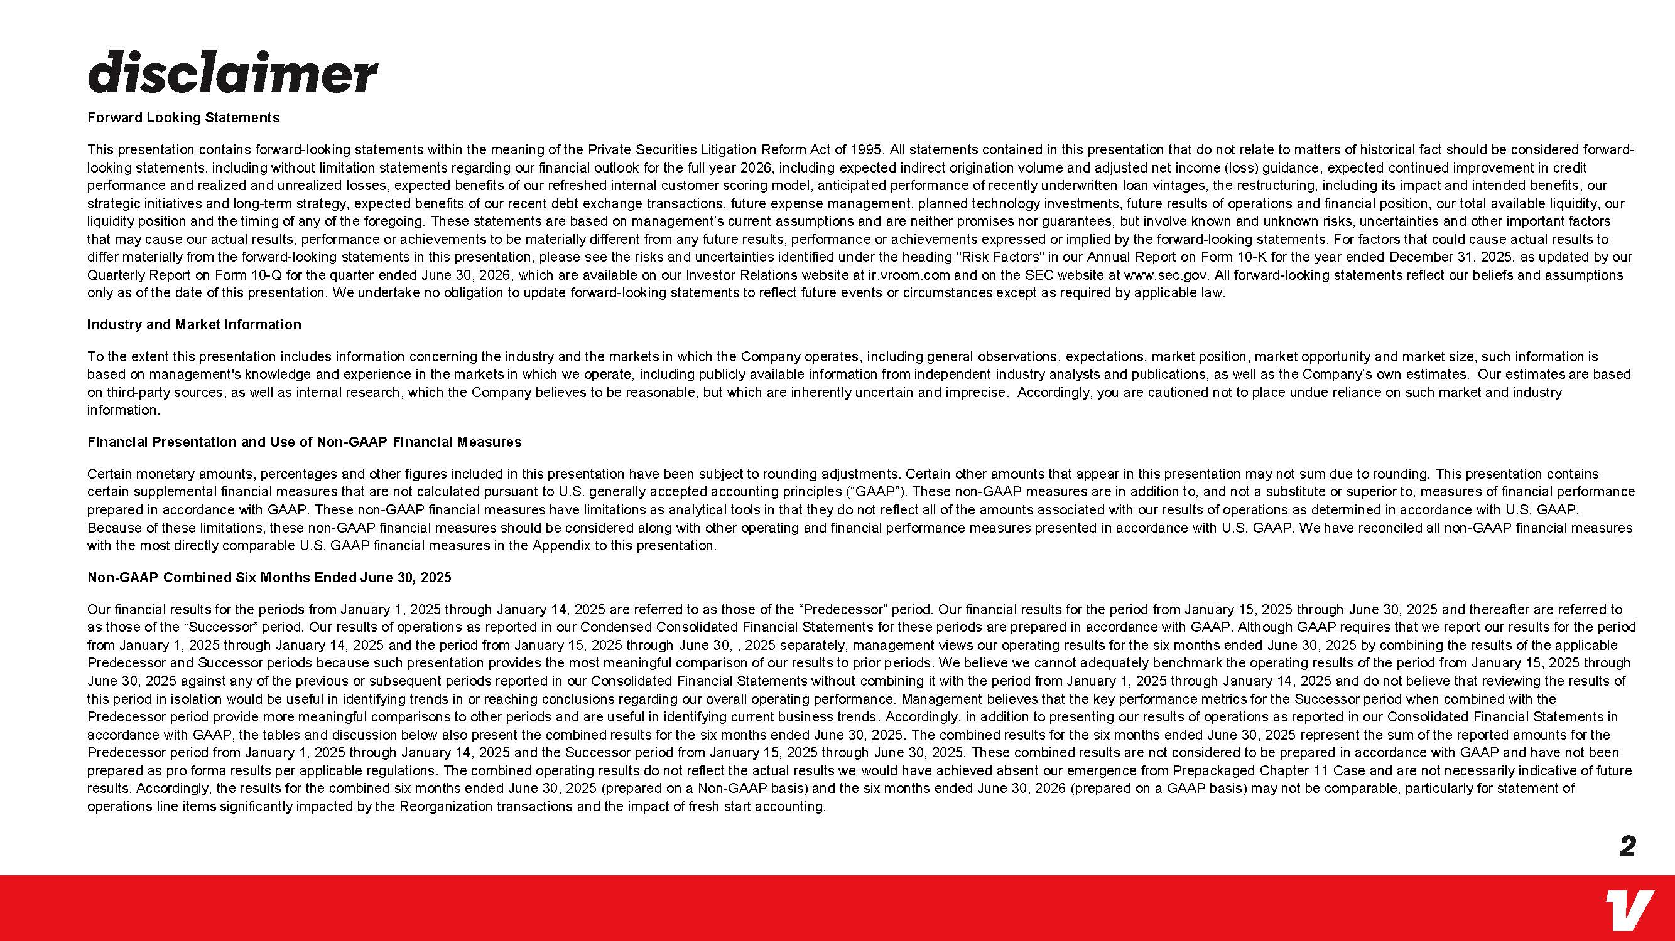
DISCLAIMER Forward Looking Statements This presentation contains forward-looking statements within the meaning of the Private Securities Litigation Reform Act of 1995. All statements contained in this presentation that do not relate to matters of historical fact should be considered forward looking statements, including without limitation statements regarding our financial outlook for the full year 2026, including expected indirect origination volume and adjusted net income (loss) guidance, expected continued improvement in credit performance and realized and unrealized losses, expected benefits of our refreshed internal customer scoring model, anticipated performance of recently underwritten loan vintages, the restructuring, including its impact and intended benefits, our strategic initiatives and long-term strategy, expected benefits of our recent debt exchange transactions, future expense management, planned technology investments, future results of operations and financial position, our total available liquidity, our liquidity position and the timing of any of the foregoing. These statements are based on management’s current assumptions and are neither promises nor guarantees, but involve known and unknown risks, uncertainties and other important factors that may cause our actual results, performance or achievements to be materially different from any future results, performance or achievements expressed or implied by the forward-looking statements. For factors that could cause actual results to differ materially from the forward-looking statements in this presentation, please see the risks and uncertainties identified under the heading "Risk Factors" in our Annual Report on Form 10-K for the year ended December 31, 2025, as updated by our Quarterly Report on Form 10-Q for the quarter ended June 30, 2026, which are available on our Investor Relations website at ir.vroom.com and on the SEC website at www.sec.gov. All forward-looking statements reflect our beliefs and assumptions only as of the date of this presentation. We undertake no obligation to update forward-looking statements to reflect future events or circumstances except as required by applicable law. Industry and Market Information To the extent this presentation includes information concerning the industry and the markets in which the Company operates, including general observations, expectations, market position, market opportunity and market size, such information is based on management's knowledge and experience in the markets in which we operate, including publicly available information from independent industry analysts and publications, as well as the Company’s own estimates. Our estimates are based on third-party sources, as well as internal research, which the Company believes to be reasonable, but which are inherently uncertain and imprecise. Accordingly, you are cautioned not to place undue reliance on such market and industry information. Financial Presentation and Use of Non-GAAP Financial Measures Certain monetary amounts, percentages and other figures included in this presentation have been subject to rounding adjustments. Certain other amounts that appear in this presentation may not sum due to rounding. This presentation contains certain supplemental financial measures that are not calculated pursuant to U.S. generally accepted accounting principles (“GAAP”). These non-GAAP measures are in addition to, and not a substitute or superior to, measures of financial performance prepared in accordance with GAAP. These non-GAAP financial measures have limitations as analytical tools in that they do not reflect all of the amounts associated with our results of operations as determined in accordance with U.S. GAAP. Because of these limitations, these non-GAAP financial measures should be considered along with other operating and financial performance measures presented in accordance with U.S. GAAP. We have reconciled all non-GAAP financial measures with the most directly comparable U.S. GAAP financial measures in the Appendix to this presentation. Non-GAAP Combined Six Months Ended June 30, 2025 Our financial results for the periods from January 1, 2025 through January 14, 2025 are referred to as those of the “Predecessor” period. Our financial results for the period from January 15, 2025 through June 30, 2025 and thereafter are referred to as those of the “Successor” period. Our results of operations as reported in our Condensed Consolidated Financial Statements for these periods are prepared in accordance with GAAP. Although GAAP requires that we report our results for the period from January 1, 2025 through January 14, 2025 and the period from January 15, 2025 through June 30, , 2025 separately, management views our operating results for the six months ended June 30, 2025 by combining the results of the applicable Predecessor and Successor periods because such presentation provides the most meaningful comparison of our results to prior periods. We believe we cannot adequately benchmark the operating results of the period from January 15, 2025 through June 30, 2025 against any of the previous or subsequent periods reported in our Consolidated Financial Statements without combining it with the period from January 1, 2025 through January 14, 2025 and do not believe that reviewing the results of this period in isolation would be useful in identifying trends in or reaching conclusions regarding our overall operating performance. Management believes that the key performance metrics for the Successor period when combined with the Predecessor period provide more meaningful comparisons to other periods and are useful in identifying current business trends. Accordingly, in addition to presenting our results of operations as reported in our Consolidated Financial Statements in accordance with GAAP, the tables and discussion below also present the combined results for the six months ended June 30, 2025. The combined results for the six months ended June 30, 2025 represent the sum of the reported amounts for the Predecessor period from January 1, 2025 through January 14, 2025 and the Successor period from January 15, 2025 through June 30, 2025. These combined results are not considered to be prepared in accordance with GAAP and have not been prepared as pro forma results per applicable regulations. The combined operating results do not reflect the actual results we would have achieved absent our emergence from Prepackaged Chapter 11 Case and are not necessarily indicative of future results. Accordingly, the results for the combined six months ended June 30, 2025 (prepared on a Non-GAAP basis) and the six months ended June 30, 2026 (prepared on a GAAP basis) may not be comparable, particularly for statement of operations line items significantly impacted by the Reorganization transactions and the impact of fresh start accounting. v 2

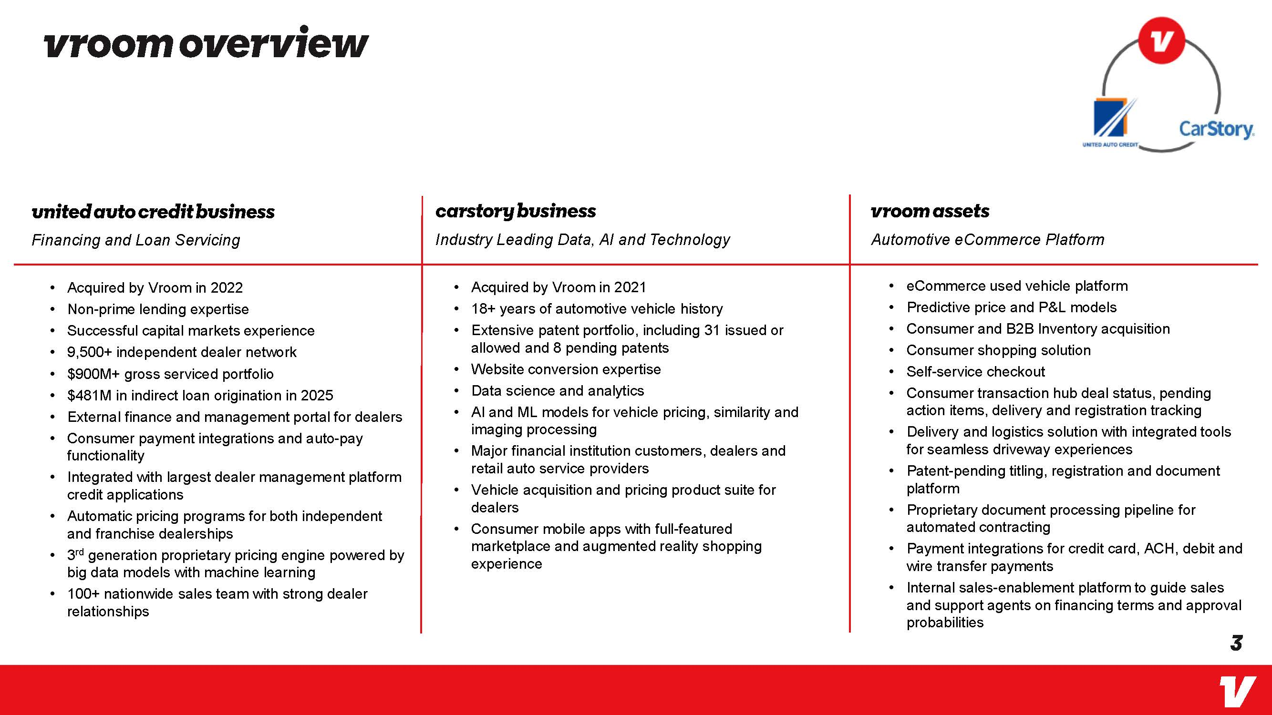
Vroom overview United auto credit business Financing and Loan Servicing  Acquired by Vroom in 2022  Non-prime lending expertise  Successful capital markets experience  9,500+ independent dealer network  $900M+ gross serviced portfolio  $481M in indirect loan origination in 2025  External finance and management portal for dealers  Consumer payment integrations and auto-pay functionality  Integrated with largest dealer management platform credit applications  Automatic pricing programs for both independent and franchise dealerships  3rd generation proprietary pricing engine powered by big data models with machine learning  100+ nationwide sales team with strong dealer relationships Carstory business Industry Leading Data, AI and Technology  Acquired by Vroom in 2021  18+ years of automotive vehicle history  Extensive patent portfolio, including 31 issued or allowed and 8 pending patents  Website conversion expertise  Data science and analytics  AI and ML models for vehicle pricing, similarity and imaging processing  Major financial institution customers, dealers and retail auto service providers  Vehicle acquisition and pricing product suite for dealers  Consumer mobile apps with full-featured marketplace and augmented reality shopping experience Vroom assets Automotive eCommerce Platform  eCommerce used vehicle platform  Predictive price and P&L models  Consumer and B2B Inventory acquisition  Consumer shopping solution  Self-service checkout  Consumer transaction hub deal status, pending action items, delivery and registration tracking  Delivery and logistics solution with integrated tools for seamless driveway experiences  Patent-pending titling, registration and document platform  Proprietary document processing pipeline for automated contracting  Payment integrations for credit card, ACH, debit and wire transfer payments  Internal sales-enablement platform to guide sales and support agents on financing terms and approval probabilities united auto credit carstory. v 3

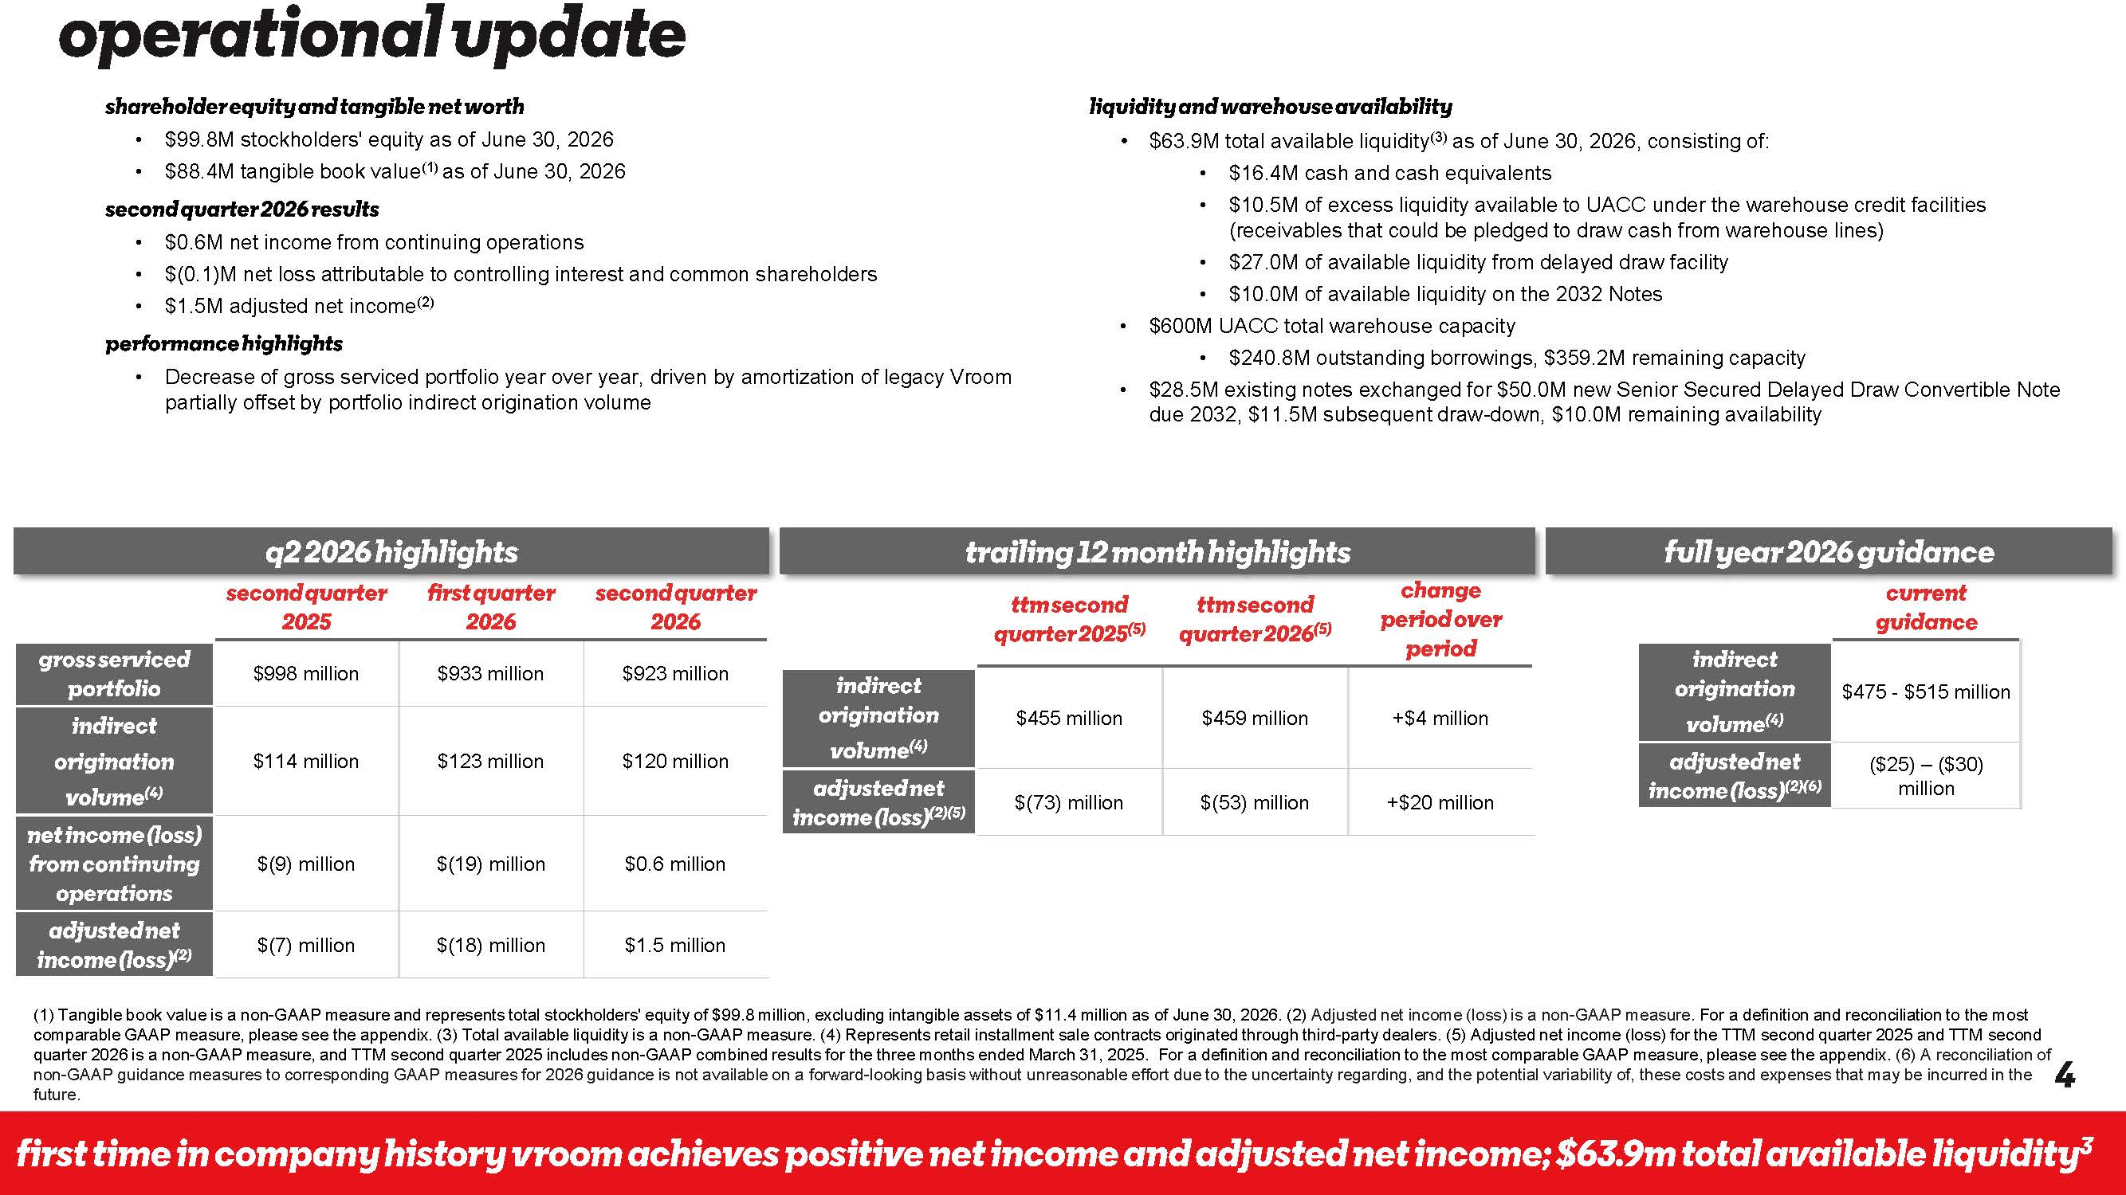
v 4 Shareholder equity and tangible net worth  $99.8M stockholders' equity as of June 30, 2026  $88.4M tangible book value(1) as of June 30, 2026 second quarter 2026 results  $0.6M net income from continuing operations  $(0.1)M net loss attributable to controlling interest and common shareholders  $1.5M adjusted net income(2) highlights  Decrease of gross serviced portfolio year over year, driven by amortization of legacy Vroom partially offset by portfolio indirect origination volume liquidity and warehouse availability  $63.9M total available liquidity(3) as of June 30, 2026, consisting of:  $16.4M cash and cash equivalents  $10.5M of excess liquidity available to UACC under the warehouse credit facilities (receivables that could be pledged to draw cash from warehouse lines)  $27.0M of available liquidity from delayed draw facility  $10.0M of available liquidity on the 2032 Notes  $600M UACC total warehouse capacity  $240.8M outstanding borrowings, $359.2M remaining capacity  $28.5M existing notes exchanged for $50.0M new Senior Secured Delayed Draw Convertible Note due 2032, $11.5M subsequent draw-down, $10.0M remaining availability Operational First Time in Company History Vroom Achieves Positive Net Income and Adjusted Net Income; $63.9 M available liquidity 3 Second 2025 First quarter 2026 2026 Gross serviced $998 million $933 million $923 million Origination Volume(4) $114 million $123 million $120 million Net income loss) $(9) million $(19) million $0.6 million Adjusted loss)(2) $(7) million $(18) million $1.5 million (1) Tangible book value is a non-GAAP measure and represents total stockholders' equity of $99.8 million, excluding intangible assets of $11.4 million as of June 30, 2026. (2) Adjusted net income (loss) is a non-GAAP measure. For a definition and reconciliation to the most comparable GAAP measure, please see the appendix. (3) Total available liquidity is a non-GAAP measure. (4) Represents retail installment sale contracts originated through third-party dealers. (5) Adjusted net income (loss) for the TTM second quarter 2025 and TTM second quarter 2026 is a non-GAAP measure, and TTM second quarter 2025 includes non-GAAP combined results for the three months ended March 31, 2025. For a definition and reconciliation to the most comparable GAAP measure, please see the appendix. (6) A reconciliation of non-GAAP guidance measures to corresponding GAAP measures for 2026 guidance is not available on a forward-looking basis without unreasonable effort due to the uncertainty regarding, and the potential variability of, these costs and expenses that may be incurred in the future. Q2 2026 Highlights Ttm second 2025(5) Ttm second quarter 2026 (5) Change Period Indirect Origination Volume(4) $455 million $459 million +$4 million Adjusted income (loss)(2)(5) $(73) million $(53) million +$20 million Trailing 12 month Highlights current Indirect Origination Volume(4) $475 - $515 million Adjusted loss)(2)(6) ($25) – ($30) million Full year 2026 guidance operational update shareholder equity and tangible net worth second quarter2026 results performance highlights q2 2026 highlights gross serviced portfolio indirect origination volume(4) net income (loss) from continuing operations adjusted net income (1oss(2) second quarter 2025 first quarter 2026 second quarter 2026 indirect origination volume(4) adjusted net income(1oss)(2)(5) liquidity and warehouse availability trailing 12month highlights ttmsecond quarter 2025(5) ttmsecond quarter2026(5) change period over period fu11year 2026guidance indirect origination volume(4) adjusted net income (1oss)(2)(6) current guidance 4 first time in company history vroom achieves positive net income and adjusted net income; $63.9m total available 1iqvidity3

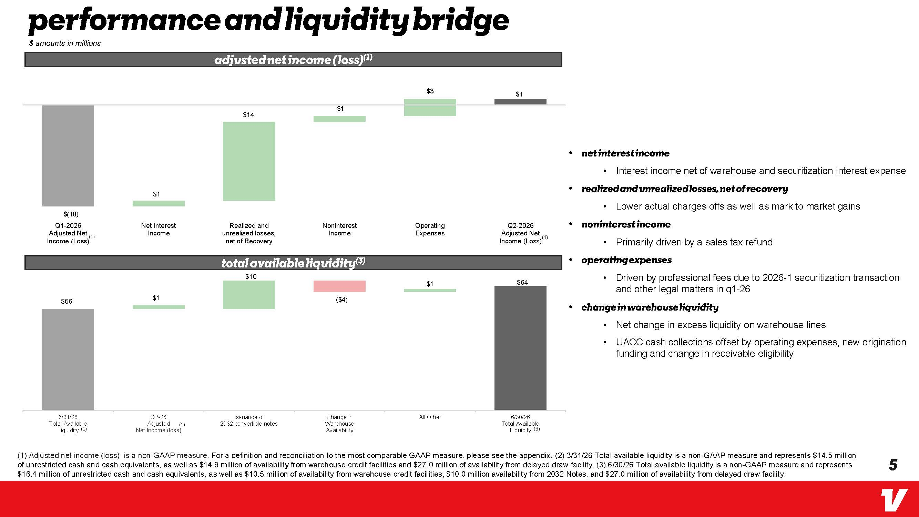
$(18) $1 $1 $14 $1 $3 Q1-2026 Adjusted Net Income (Loss) Net Interest Income Realized and unrealized losses, net of Recovery Noninterest Income Operating Expenses Q2-2026 Adjusted Net Income (Loss) Performance and liquidity bridge (1) Adjusted net income (loss) is a non-GAAP measure. For a definition and reconciliation to the most comparable GAAP measure, please see the appendix. (2) 3/31/26 Total available liquidity is a non-GAAP measure and represents $14.5 million of unrestricted cash and cash equivalents, as well as $14.9 million of availability from warehouse credit facilities and $27.0 million of availability from delayed draw facility. (3) 6/30/26 Total available liquidity is a non-GAAP measure and represents $16.4 million of unrestricted cash and cash equivalents, as well as $10.5 million of availability from warehouse credit facilities, $10.0 million availability from 2032 Notes, and $27.0 million of availability from delayed draw facility. $56 $64 $1 $10 ($4) $1 3/31/26 Total Available Liquidity Q2-26 Adjusted Net Income (loss) Issuance of 2032 convertible notes Change in Warehouse Availability All Other 6/30/26 Total Available Liquidity  Net interest income  Interest income net of warehouse and securitization interest expense  Realized losses, net of recovery  Lower actual charges offs as well as mark to market gains  Noninterest income  Primarily driven by a sales tax refund  Operating expenses  Driven by professional fees due to 2026-1 securitization transaction and other legal matters in q1-26  Change liquidity  Net change in excess liquidity on warehouse lines  UACC cash collections offset by operating expenses, new origination funding and change in receivable eligibility (2) (3) (1) $ amounts in millions Total available liquidity (3) Adjusted net income (loss) (1) (1) (1) performance and liquidity bridge adjusted net income (1oss)(1) w net interest income realized and unrealized losses, net of recovery noninterest income total available liquidity(3) operating expenses - change in warehouse liquidity v 5

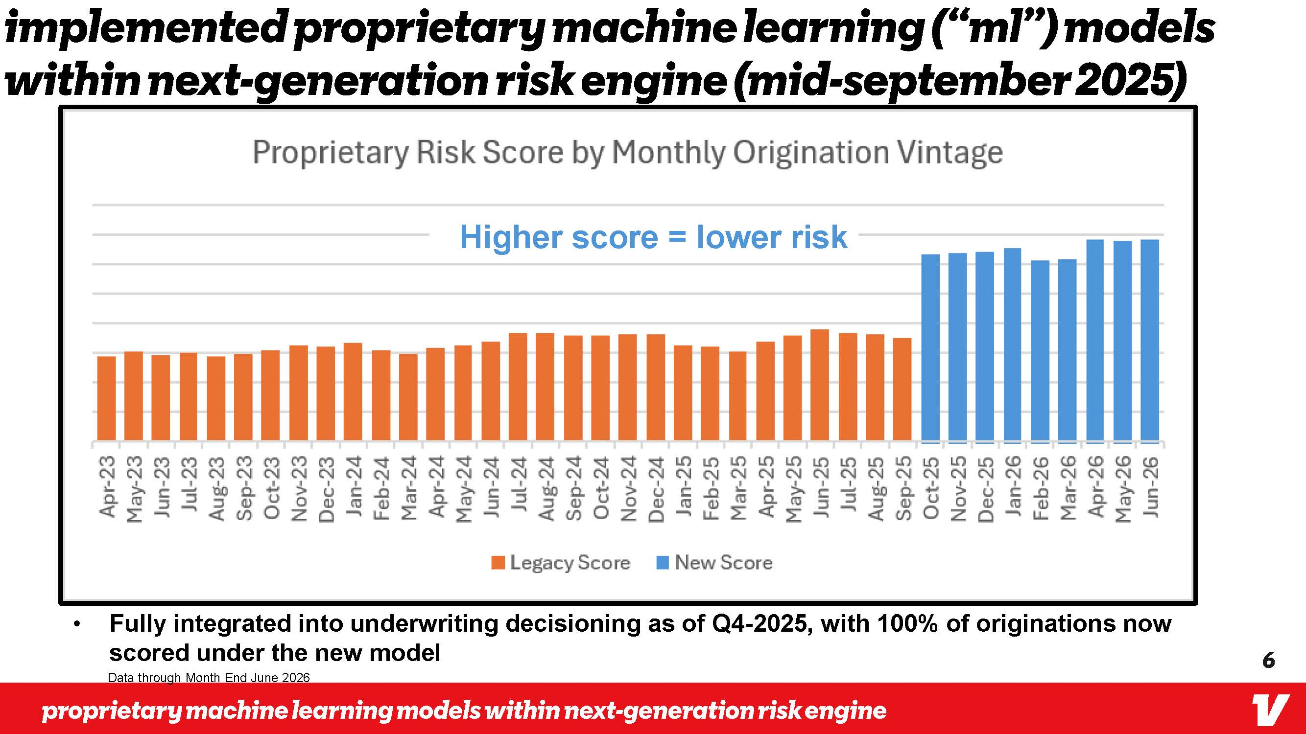
proprietary machine learning models within Next -generation risk engine v Data through Month End June 2026  Fully integrated into underwriting decisioning as of Q4-2025, with 100% of originations now scored under the new model Implemented proprietary machine learning (“ML”) models within Next -generation risk engine (mid -September 2025) Higher score = lower risk Apr-23 May 23 Jun-23 Jul-23 Aug-23 Sep-23 Oct-23 Nov-23 Dec-23 Jan-24 Feb-24 Mar-24 Apr-24 May-24 Jun-24 Jul-24 Aug-24 Sep~24 Oct-24 Nov-24 Dec-24 Jan-25 Feb-25 Mar-25 Apr-25 May-25 Jun-25 Jul-25 Aug-25 Sep-25 Oct-25 Nov-25 Dec-25 Jan-26 Feb-26 Mar-26 Apr-26 May-26 Jun-26 Legacy Score New Score 6 v

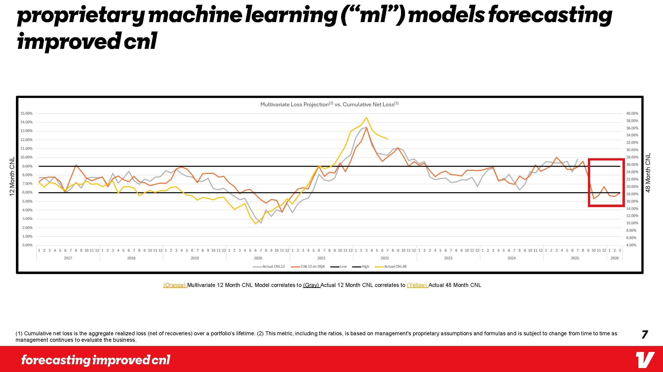
proprietary machine learning (“ML”) models forecasting improved CNL Forecasting improved CNL (1) Cumulative net loss is the aggregate realized loss (net of recoveries) over a portfolio’s lifetime. (2) This metric, including the ratios, is based on management's proprietary assumptions and formulas and is subject to change from time to time as management continues to evaluate the business. (Orange) Multivariate 12 Month CNL Model correlates to (Gray) Actual 12 Month CNL correlates to (Yellow) Actual 48 Month CNL Multivariate Loss Projection!2l vs. Cumulative Net Loss{1} 12 Month CNL 15.00% 14.00% 13.00% 12.00% 11.00% 10.00% 9.00% 8.00% 7.00% 6.00% 5.00% 4.00% 3.00% 2.00% 1.00% 0.00% 48 Month CNL 40.00% 38.00% 36.00% 34.00% 32.00% 30.00% 28.00% 26.00% 24.00% 22.00% 20.00% 18.00% 16.00% .14.00% 12.00% 10.00% 8.00% 6.00% 4.00% 1 2 3 4 5 6 7 8 9 10 1112 1 2 3 4 5 6 7 8 9 10 1112 1 2 3 4 5 6 7 8 9 10 11 12 1 2 3 4 5 6 7 8 9 10 11 12 1 2 3 4 5 6 7 8 9 10 1112 1 2 3 4 5 6 7 8 9 10 1112 1 2 3 4 5 6 7 8 9 10 1112 1 2 3 4 5 6 7 8 9 10 1112 1 2 3 4 5 6 7 8 9 10 1112 1 2 3 2017 2018 2019 2020 2021 2022 2023 2024 2025 2026 ActualCNL12 CNL12 on DQ4 Low High Actual CNL48 7 forecasting improved cnl V 7

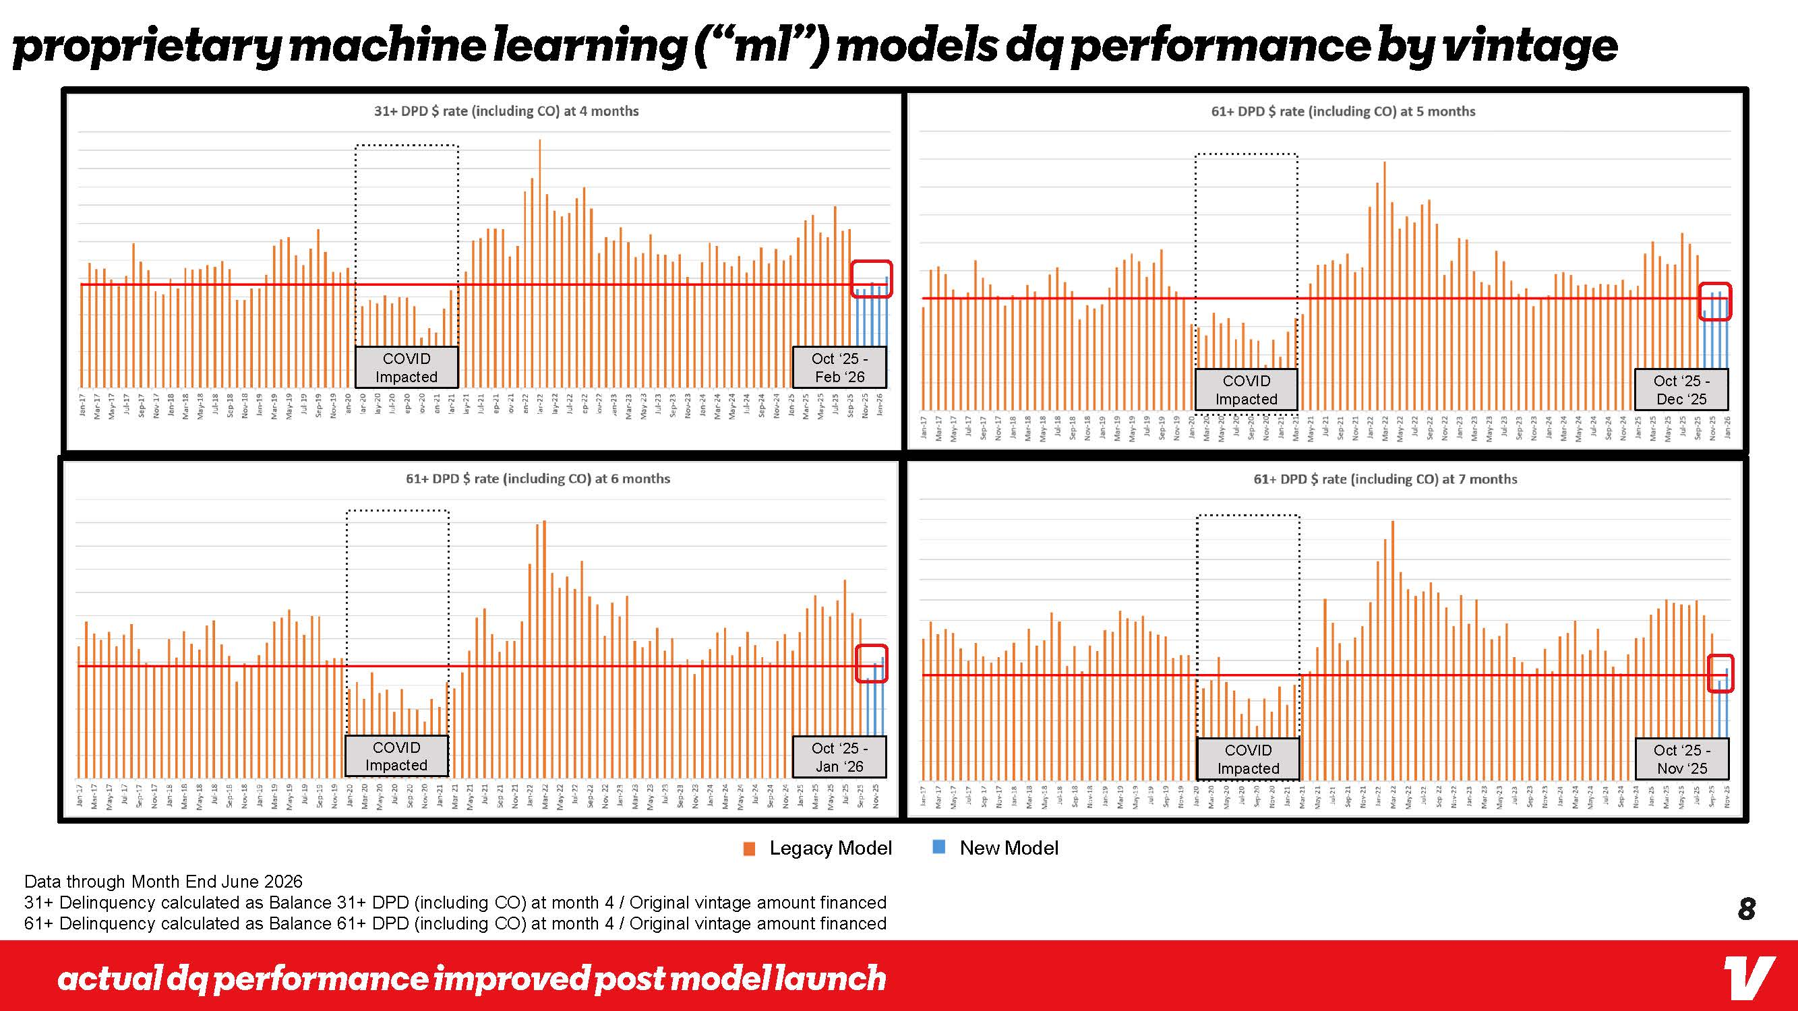
proprietary machine learning (“ML”) models dq performance by vintage Actual dq performance improved post model launch v COVID Impacted Oct ‘25 -Feb ‘26 COVID Impacted COVID Impacted COVID Impacted Oct ‘25 - Jan ‘26 Oct ‘25 - Dec ‘25 Oct ‘25 - Nov ‘25 Data through Month End June 2026 31+ Delinquency calculated as Balance 31+ DPD (including CO) at month 4 / Original vintage amount financed 61+ Delinquency calculated as Balance 61+ DPD (including CO) at month 4 / Original vintage amount financed Legacy Model New Model Jan-17 Mar-17 May-17 Jul-17 Sep-17 Nov-17 Jan-18 Mar-18 May-18 Jul-18 Sep-18 Nov-18 Jan-19 Mar-19 May-19 Jul-19 Sep-19 Nov-19 Jan-20 Mar-20 May-20 Jul-20 Sep-20 Nov-20 Jan-21 Mar-21 May-21 Jul-21 Sep-21 Nov-21 Jan-22 Mar-22 May-22 Jul-22 Sep-22 Nov-22 Jan-23 Mar-23 May-23 Jul-23 Sep-23 Nov-23 Jan-24 Mar-24 May-24 Jul-24 Scp-24 Nov-24 Jan-25 Mar-25 May-25 Jul-25 Sep-25 Nov-25 Mar-17 May-17 Jul- 17 Sep-17 Jar..18 Mar-18 May-18 Jul-18 Sep-18 Mar-19 May-19 Jul-19 Sep-19 Nov-19 Jarn-20 May-20 Jul-20 Sep-20 Nov-20 Mar-21 May-21 Jul-21 Sep-21 Nov-21 Jan-22 May-22 Jul-22 Sep-22 Mar-23 May-23 Jul-23 Sep-23 Nov-23 Jan-24 May-24 Jul-24 Sep-24 Mar-25 May-25 Jul-25 Sep-25 Nov-25 Jan-17 Mar-17 May-17 Jul-17 Sep-17 Nov-17 Jan-18 Mar-18 May-18 Jul-18 Sep-18 Nov-18 Jan-19 Mar-19 May-19 Jul-19 Sep-19 Nov-19 Jan-20 Mar-20 May-20 Jul-20 Sep-20 Nov-20 Jan-21 Mar-21 May-21 Jul-21 Sep-21 Nov-21 Jan-22 Mar-22 May-22 Jul-22 Sep-22 Nov-22 Jan-23 Mar-23 May-23 Jul-23 Sep-23 Nov-23 Jan-24 Mar-24 May-24 Jul-24 Sep-24 Nov-24 Jan-25 Mar-25 May-25 Jul-25 Sep-25 Nov-25 Jan-26 Jan-17 Mar-17 May-17 Jul-17 Scp-17 Nov-17 Jan-18 Mar-18 May-18 Jul-18 Sep-18 Nov-18 Jan-19 Mar-19 May-19 Jul-19 Sep-19 Nov-19 Jan-20, Mar-20 May-20 Jul-20 Sep-20 Nov-20 Jan-21 Mar-21 May-21 Jul-21 Sep-21 Nov-21 Jan-22 Mar-22 May-22 Jul-22 Scp-22 Nov-22 Jan-23 Mar-23 May-23 Jul-23 Sep-23 Nov-23 Jan-24 Mar-24 May-24 Jul-24 Sep-24 Nov-24 Jan-25 Mar-25 May-25 Jul-25 Scp-25 Nov-25 Jan-26 31+ DPD $ rate (including CO) at 4 months 61+ DPD $ rate (including CO) at 5 months 61+ DPD $ rate (including CO) at 6 months 61+ DPD $ rate (including CO) at 7 months v 8

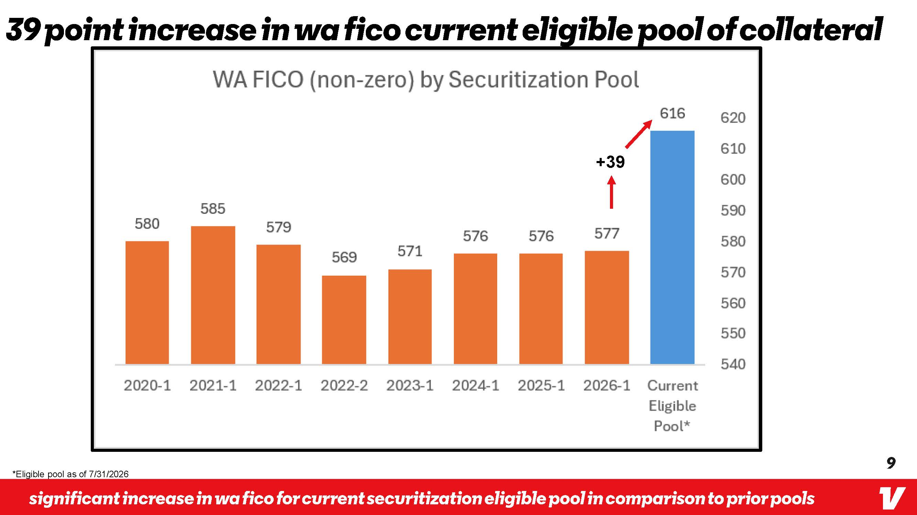
39 point increase in WA fico current eligible pool of Collateral WA FICO (non-zero) by Securitization Pool 580 585 579 569 571 576 576 577 +39 616 2020-1 2021-1 2022-1 2022-2 2023-1 2024-1 2025-1 2026-1 Current Eligible Pool* *Eligible pool as of 7/31/2026 620 610 600 590 580 570 560 550 540 Significant increase in WA fico for current securitization eligible pool in comparison to prior pools v 9


10 v Appendix vroom

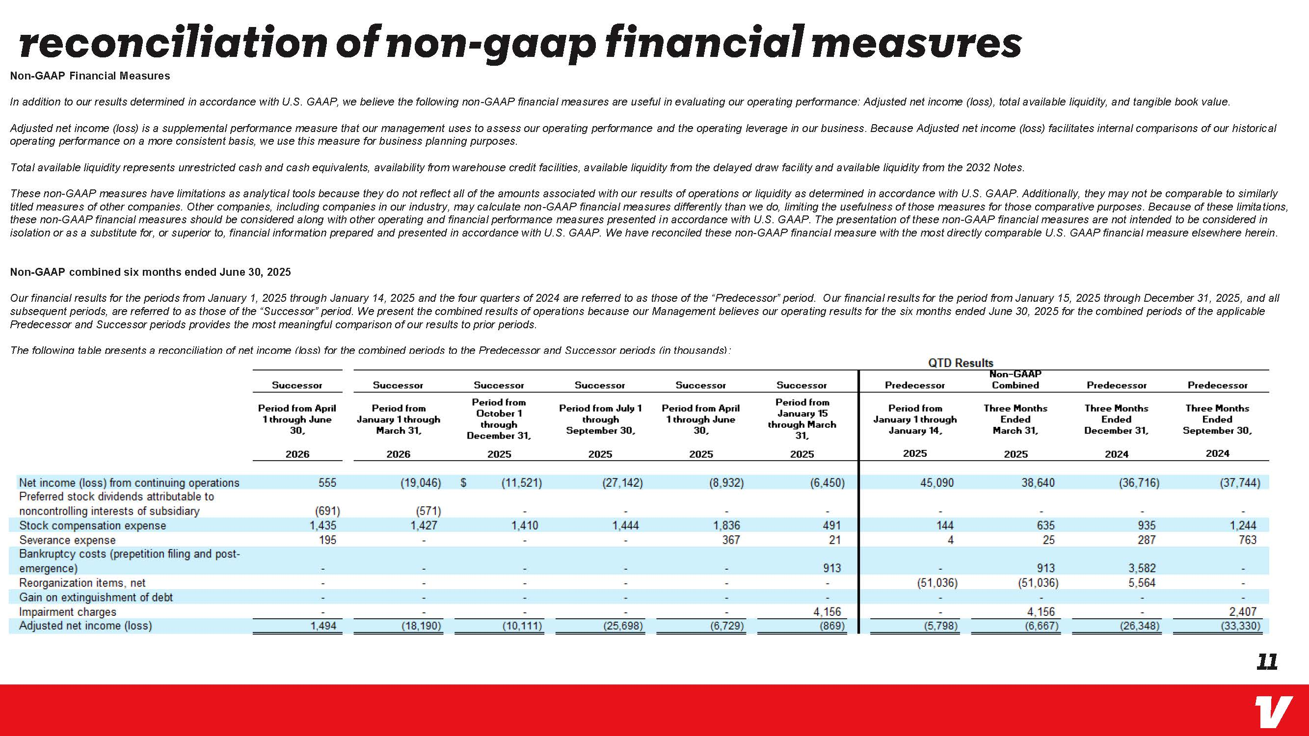
reconciliation of non-goop financial measures Non-GAAP Financial Measures In addition to our results determined in accordance with U.S. GAAP, we believe the following non-GAAP financial measures are useful in evaluating our operating performance: Adjusted net income (loss), total available liquidity, and tangible book value. Adjusted net income (loss) is a supplemental performance measure that our management uses to assess our operating performance and the operating leverage in our business. Because Adjusted net income (loss) facilitates internal comparisons of our historical operating performance on a more consistent basis, we use this measure for business planning purposes. Total available liquidity represents unrestricted cash and cash equivalents, availability from warehouse credit facilities, available liquidity from the delayed draw facility and available liquidity from the 2032 Notes. These non-GAAP measures have limitations as analytical tools because they do not reflect all of the amounts associated with our results of operations or liquidity as determined in accordance with U.S. GAAP. Additionally, they may not be comparable to similarly titled measures of other companies. Other companies, including companies in our industry, may calculate non-GAAP financial measures differently than we do, limiting the usefulness of those measures for those comparative purposes. Because of these limitations, these non-GAAP financial measures should be considered along with other operating and financial performance measures presented in accordance with U.S. GAAP. The presentation of these non-GAAP financial measures are not intended to be considered in isolation or as a substitute for, or superior to, financial information prepared and presented in accordance with U.S. GAAP. We have reconciled these non-GAAP financial measure with the most directly comparable U.S. GAAP financial measure elsewhere herein. Non-GAAP combined six months ended June 30, 2025 Our financial results for the periods from January 1, 2025 through January 14, 2025 and the four quarters of 2024 are referred to as those of the “Predecessor” period. Our financial results for the period from January 15, 2025 through December 31, 2025, and all subsequent periods, are referred to as those of the “Successor” period. We present the combined results of operations because our Management believes our operating results for the six months ended June 30, 2025 for the combined periods of the applicable Predecessor and Successor periods provides the most meaningful comparison of our results to prior periods. The following table presents a reconciliation of net income (loss) for the combined periods to the Predecessor and Successor periods (in thousands): QTD Results Successor Successor Successor Successor Successor Successor Predecessor Non-GAAP Combined Predecessor Predecessor Period from April Period from Period from Period from Jull} 1 Period from April Period from Period from Three Months Three Months Three Months October 1 January 15 1 through June January 1 through through through 1 through June through March January 1 through Ended Ended Ended 30, March 31, December 31, September 30, 30, 31, January 14, March 31, December 31, September 30, 2026 2026 2025 2025 2025 2025 2025 2025 2024 2024 Net income (loss) from continuing, operations 555 (19,046) $ (11 ,521 ) (27,142) (8,932) (6,450) 45,090 38,640 (36,716) (37,744) Preferred stock dividends attributable to noncontrolling, interests of subsidiary (691 ) (571) - - - - - - - Stock compensation expense 1,435 1,427 1,410 1,444 1,836 491 144 635 935 1,244 Severance expense 195 - - - 367 21 4 25 287 763 Bankruptcy costs (pre-petition filing, and post-emergence) - - - - - 913 - 913 3,582 - Reorganization items, net - - - - - - (51,036) (51,036) 5,564 - Gain on extinguishment of debt - - - - - - - - - - Impairment charges - - - - - 4,156 - 4,156 - 2,4 07 Adjusted net income (loss) 1,494 (18,190) (10,111) (25,698) (6,729) (869) (5,798) (6,667) (26,34 8) (33,330) 11 v

